CONNECT 2021-2024

Connecting universities-industry through smart entrepreneurial cooperation and competitive intelligence of students in Moldova, Georgia and Armenia

|  |  |
| --- | --- |
| Project Acronym: | CONNECT |
| Project Title: | Connecting universities-industry through smart entrepreneurial cooperation and competitive intelligence of students in Moldova, Georgia and Armenia |
| Project No: | 617393-EPP-1-2020-1-MD-EPPKA2-CBHE-JP |
| Funding Scheme: | ERASMUS+ |
| Coordinator: | Moldova State University  (MSU) |
| Project Duration: | 3 years (starting January 2021) |

**DX.X [Title of Deliverable]**

**Training Material on Acceleration/Art/Digital Skills**

|  |  |
| --- | --- |
| Work Package: | WP2 |
| Lead Beneficiary: | UNACT |
| Submission Date: | 15/09/2021 |
| Dissemination Level: | Public |

*The contents of this document are the sole responsibility of [XXXXXXX PARTNER] and can under no circumstances be regarded as reflecting the position of the European Union.*

**TRAINING MODULE ON ACCELERATION**

**Advanced Acceleration: From Idea to Business Concept - An Entrepreneurial Journey**

The training Module on Advanced Acceleration: From Idea to Business Concept - An Entrepreneurial Journey is for trainers, early stage and incorporated startups and teachers to use in non-formal education settings.

Contributors and Editors: XXx,Xxxx; XXX, XXX;

Project: CONNECT - Connecting universities-industry through smart entrepreneurial cooperation and competitive intelligence of students in Moldova, Georgia and Armenia

Funded by: Erasmus+ Programme

Partners:

[Partner Logos]

DISCLAIMER

The European Commission support for the production of this publication does not constitute an endorsement of the contents which reflects the views only of the authors, and the Commission cannot be held responsible for any use which may be made of the information contained therein.

Use of the content for non commercial use is authorized, provided the source is acknowledged

© XXXXXXX – CONNECT Project 617393-EPP-1-2020-1-MD-EPPKA2-CBHE-JP

**Table of Contents**

Introduction 6

Part A 8

1 Chapter 1: Needs discovery and validation methods for startups 8

1.1 Problem and Need: Two different things 8

1.2 Start Smart: Delineate Uniqueness and conduct market research 8

1.3 Get a grasp of where the competition sits 9

1.4 The Lean Startup Methodology 9

1.5 Ask the right questions 10

2 Chapter 2: Competition Basics 11

2.1 Types of Competition 12

Part B 14

3 Chapter 3: Business Models 14

3.1 Essential elements for a business model 14

3.2 Examples of Business Models 15

3.3 Metrics for understanding Business Models 17

3.4 The Business Model Canvas 20

3.5 Can the Business Model Canvas be wrong? 21

4 Business Models for Social Enterprises 23

4.1 A social enterprise 24

5 Market Segmentation 26

5.1 Customer Profiling 27

5.2 The Minimum Viable Product 28

5.3 Market Fit 28

**Introduction**

A successful startup begins with a good idea. However, from the moment the idea is conceived and until a startup grows, it goes through a series of maturity phases that determine their viability. For many first-timers with great ideas, the process can be exciting but also complex. Tactics put in place for moving a “great idea” to addressing a real market need or for obtaining a market share requires: a) definition and validation of the need and analysis of the competition, and b) understanding the synthesis of the targeting market segments, defining revenue models, and penetrating the market successfully obtaining viable share in it.

**Course Description**

This training module is for startup entrepreneurs who are working towards realizing a business idea and are either in their very first steps of conceptualization, or have initiated processes of designing business and revenue models or types of agreements for market penetration.

The training material provides an introduction to the relevant business theory, as well as useful links for experiential learning and resources for further reading.

**Learning Outcomes**

By the end of this module, students will be able to:

* identify and validate a market need
* understand the importance of market research for the successful introduction of a new product.
* analyze the competition and identify a competitive advantage
* evaluate and design a business model for a successful concept based on the customer profile
* analyze and design the right types of agreements for market penetration /distribution

**Course Format**

The course format integrates:

* Online lectures with slides (ppt)
* Video Lectures
* Explanatory material (present) analyzing lecture slides along with useful weblinks and other resources
* A quiz integrating material with “Advanced Acceleration: From Idea to Business Concept: An Entrepreneurial Journey” module

**Suggested resources**

* Talking to Humans: Success Starts with Understanding Your Customers – by Giff Constable & Frank Rimalovski
* The Four Steps to the Epiphany by Steve Blank
* The Lean Startup, Author: Eric Ries, Publisher: Crown Publishing Group
* Zero to One, Authors: Peter Thiel, Blake Master
* The Startup Owner's Manual, Authors: Steve Blank, Bob Dorf, Google Books
* Start Something That Matters, Author: Blake Mycoskie
* Business Model Generation: A Handbook for Visionaries, Game Changers, and Challengers, Authors: Alexander Osterwalder, Yves Pigneur
* Blue Ocean Strategy: How to Create Uncontested Market Space and Make Competition Irrelevant by R. Mauborgne and W. C. Kim
* [The Top 20 Reasons Startups Fail](•%09https:/www.cbinsights.com/research/startup-failure-reasons-top)
* [6 Problems with the Business Model Canvas](https://www.thepourquoipas.com/post/problems-with-the-business-model-canvas)

# **Part A**

# Chapter 1: Needs discovery and validation methods for startups

## Problem and Need: Two different things

Identifying a problem does not necessarily mean that the targeted customers have the need or are looking for a solution. Customers may already solve the problem in some other way today. It is therefore important to explore and discover how the customers are currently covering their need and with what type of solution/alternative solve their problem. One of the reasons startups fails is because their business is not addressing a real market need. Decrypting all the elements of the problem and how those rank individually in the perception of the customer is critical. Many startups often do not delineate the problem characteristics as soon as they come up with a business idea.

## Start Smart: Delineate Uniqueness and conduct market research

Standing out from the crowd or “uniqueness” of a business idea is a key consideration of startups in a competitive landscape. This is because when barriers to entry are relatively low or the innovation can be quickly replicated, startups need to identify a different position and carve out a competitive edge. Uniqueness is often projected as an advantage by inventors or founders. However, this is not always the case. Often the product is not as unique as believed or there are cases, where “uniqueness” is the outcome of market need absence. Both startups and mentors should pay attention when structuring the argument of “uniqueness” or when the competitive advantage of a solution is examined. Argumentation for why and how a startup can stand out from the crowd should be based on need validation and extensive market and competition analysis.

Exploring existing knowledge offers a first step to understand the market and the problem. Secondary research includes reports and studies by government agencies, trade associations or other businesses in an industry. Today, a lot of secondary research is available right on the Web, simply by entering key words and phrases for the type of information you’re looking for. Information can also be obtained during secondary research by reading articles in magazines, trade journals and industry publications, and by contacting industry associations or trade organizations. (Note: always check the publication date if a report to be sure the data is not outdated.) One excellent source of secondary research data is government agencies; this data is usually available free of charge. On the other hand, data published by private companies may require permission, and sometimes a fee.

Many sources offer important data and insights on market developments as well as trends related to products or services. Decrypting the explored information and understanding the market and the competition in the sector of interest, as well as mapping the available options for the customers, offers valuable business intelligence and can save startups from the trouble of implementation based on wrong assumptions.

## Get a grasp of where the competition sits

To get a better grasp of where competition sits, it might help to create a graph that places companies in different buckets (e.g., free, freemium, premium, SMB, quality, etc.). By doing a competition analysis, a startup can better understand what are the best opportunities to stake a claim on how it is different or unique. Both direct and indirect competition needs to be mapped to explore the competitive landscape. This can be done with the help of a perceptual map that will reveal the “big picture” for the wannabe entrepreneur.

## The Lean Startup Methodology

The Lean Startup Methodology [ <http://theleanstartup.com/> ] by Eric Ries under the “Build – Measure – Learn” core concept, can help startups validate a market need in much cheaper and easy ways than in the past. The “Build-Measure-Learn” is a framework for establishing – and continuously improving – the effectiveness of new products, services and ideas quickly and cost-effectively. In practice, the model involves a cycle of creating and testing hypotheses by building something small for potential customers to try, measuring their reactions, and learning from the results. The aim is to continuously improve the business offering so that you eventually deliver precisely what your customers want.

Build-Measure-Learn may sound simplistic, but it has proved a game-changing technique for startups because of getting potential customers' input. Although sometimes, startups would get lucky, many spend a lot of time and money-making sophisticated products that no one wants. Build-Measure-Learn improves the process of solving a real market need, adopting an iterative methodology that replaces assumption with knowledge and certainty.

One of the phrases that is often used by scholars and mentors of the Lean Start Up practitioners is “Get out of the Building” and emphasizes the need of the startup founders to communicate directly with the market and do that as fast as possible. Communicating with the real market, users, clients, suppliers etc. of a value chain can detect early what the market really needs, it’s mechanics, the problem existence and its intensity, alternative solutions as well as barriers to entry.

The Lean Startup Methodology is based on Steve Blanks theory pointing out the problems of applying emphasis on product development instead of "customer development", and early learning about customers and their problems. Steve Blanks theory is analyzed in his book *The Four Steps to the Epiphany: Successful Strategies for Products that Win* (2005, 5th edition 2013).

## Ask the right questions

Asking the right questions is important to understand better any secondary data collected, information on hand and validate assumptions. In primary research, asking the right set of questions follows a basic rule: we do not ask if people would adopt or buy the proposed solution in the future… These types of questions may cause biased answers because of the potential customer’s desire to test and explore a new product, but gives no evidence if the customer would eventually buy it, when the product would be available. Exploring the real reasons about the market pain, the need for a better solution and desire to adopt it, is done by seeking for signs and indications on the customers/users past and present behavior. That happens because no one can simply tell you how he/she will behave in the future. A set of indicative question to depict your client’s needs are the following:

**Situation Depiction**

1. Can you tell me more about the last time you did [X]?
2. What are the reasons you do [X]?
3. How often do you do [X]?

**Problem Description and Size**

1. What are you trying to achieve /get done by doing [X]?
2. Could you describe step by step how you do [X]?
3. Which step is the most time-consuming / most difficult / most expensive?
4. Can you quantify this? (e.g. “losing 20min per day”)
5. Why is that?

**Problem parameters**

1. If you could take out / avoid one step, which would you pick?
2. Why did you decide to go for this solution/process?
3. How often do you experience problem [X]?
4. What happens before/after you experience problem [X]?

**Exploring the need for a solution**

1. Did you ever compare alternative solutions to solve a problem [X]?
2. What don’t you like about [X]?
3. How would you compare this (negative experience) to [X]?
4. Can you show me how you do [X]?
5. Have you ever tried to improve [X]?
6. Can you describe your solution [X]?

**Need Intensity**

1. Would you change anything today?
2. Have you ever paid to solve it in the past?
3. What is the maximum you have paid to tackle the problem [X]?
4. Are you paying for a solution today?

**Follow your assumptions’ validation process**

1. Can help you profile better the need
2. Can lead you towards the Minimum Viable Segment Identification
3. Prevent you from building unnecessary / wrong solutions
4. Can help you see for the right help

# Chapter 2: Competition Basics

One of the most important things that startups need to understand is that they will always have competition with another venture in the market. This is because almost nothing is organic. People tend to collect, combine and create ideas based on other people’s ideas. In addition, there are very few problems or needs that are not being addressed or solved in some way right now. Therefore, what matters most is the execution. Therefore, what a startup needs to understand first is what type of competition exists in the market addressed.

When we look at competition, we are essentially answering the question: “How are people solving the problem/need ***today***?” In other words, *what solutions/products* ***exist in the market right now*** that people choose to buy/consume/utilize to address the **need** that *our business/product/service* seeks to solve?

***Example:*** you have developed a new design that depicts time in a different way from existing tools (watches, clocks, sundials). Your design not only shows the passing of time (like we are used to) but also shows how time exists in other dimensions (based on, let’s say, Einstein’s theory of relativity). You want to produce timepieces with this design. Look at the competition in your industry.

## Types of Competition

Understanding the competitors requires a systematic exploration process and is not limited to a simple Google search. For each competitor identified, one must take a good look at their products, business model (including pricing), sales channels, customer/user opinion, marketing strategies/positioning, weaknesses and more. The more information you acquire about your competitors, the more likely you are to find the missing piece – of the problem that no one has managed to solve yet – the thing that sets you apart from your competition: your Competitive Advantage.

**Direct Competition ~** are competitors, who target the same type of consumers and have a similar product or targeting the same niche market achieve the same thing.

**Indirect Competition ~** are competitors thatmay offer a similar product to a completely different audience.

**Tertiary Competition:** ~ are competitors that are tangentially related to your startup. They could offer related products and services that are trending, but they can also be businesses that may be beneficial to partner with.

***Note:*** *many times, the indirect competition can be stronger than the direct competition.* For instance, the greatest competition to a watch seller is probably not the other watch sellers or brands, but **mobile phones**. In this case, they are strong competitors because most people already have one, and most people use them to tell time.

Once the above is figured out, the subsets of the competition need to be difined.

**Actual competition** ~ are business that are currently in the market a startup would like to address.

**Potential competition** ~ are businesses to come. They are business that can invest the resources required, so that they can build something similar or something better soon and can swipe you out your spot.

The extensive research on the competition can reveal your competitive advantage but then you need to understand why that part of the problem/need i.e., the element where you would like to base your competitive advantage has not been solved yet. It is entirely probable that the reason no one has tackled the problem the way you wish to tackle is because customers don’t require the specific solution, or it is too expensive for them (because of the production cost).

**Example:** If a startup produces a watch that shows time in other dimensions, then the cost of producing it, is a lot higher than the customer will pay for this feature. Or customers don’t care about seeing time in other dimensions.

When the position of a startup is related to the competition, then they can build more appropriate strategies for producing, marketing, and selling our product.

# **Part B**

# Chapter 3: Business Models

|  |
| --- |
| **Resources:**   * [**The theory of the Business**](https://hbr.org/1994/09/the-theory-of-the-business) * [**Why Business Model matter**](https://hbr.org/2002/05/why-business-models-matter) * [**The hard truth about business model innovation**](https://sloanreview.mit.edu/article/the-hard-truth-about-business-model-innovation/) |

In Business Theory, the term” Business Model” was first introduced by Peter Drucker in the late 1990s. When starting a new business, there is need to identify a scalable business model for your product. Business Models provide an outline of how a company plans to make money with its product and customer base in a specific market depicting: a) what product or service a company sells; b) to whom it will sell the product; c) how it intends to market the product; d) what resources are required to produce the product, e) what kind of expenses the company will face, f) how it expects to reach profit from it.

## Essential elements for a business model

Business models vary in the form or the function, however they all share the same elements: a unique value proposition, a viable target market, and a competitive advantage. Without these elements it is unlikely that a business can generate profit. Business models are not only about making money, and therefore the key components a business should think about when creating one are:

* **Value proposition:** A feature that makes a product attractive to customers.
* **Target market:** A specific group of consumers who would be interested in the product.
* **Competitive advantage:** A unique feature of a product or service that can’t easily be replicated by competitors.
* **Cost structure:** A list of the fixed and variable expenses a business requires to function, and how these affect pricing.
* **Key metrics:** The ways a company measures success.
* **Resources:** The physical, financial, and intellectual assets of a company.
* **Problem and solution:** The target customers’ pain points, and how the business intends to meet them.
* **Revenue model:** A framework that identifies viable income sources to pursue.
* **Revenue streams:** The multiple sources your company can generate income.
* **Profit margin:** The amount the revenue exceeds business costs.

In the beginning of formulating a business model, many of the above elements will not be clear enough. However, as a business concept matures and while writing a business plan, the details of defining those important elements will become more evident.

## Examples of Business Models

There are many types of business models, which can be customized or changed based on the specific company or industry. Some of those types of business models are explained below, however the list is not exhaustive and many more types can be found.

**1. Subscription model**

A subscription business model: can be applied to both traditional brick-and-mortar businesses or an online businesses. The customer pays a recurring payment on a monthly basis (or another specified timeframe) for access to a service or product.

Examples: Businesses using the subscription model include gyms, Microsoft Office 365, Netflix.

**2. Bundling model:** companies sell two or more products together as a single unit. They often charge a lower price for those than they would charge selling the products separately. Although bundling allow a business model to generate a greater volume of sales it may cause lower profit margins since businesses sell the products for less.

Examples: Businesses that use the bundling model include Adobe Creative Suite, Burger King, McDonalds as well as other fast-food companies that offer value meals or deals.

**3. Freemium model:** a company offers free access to a product or service, however, the company withholds or limits the use of certain key features that, over time, their users will likely want to use more regularly. To gain access to those key features, users must pay for a subscription.

Examples: Spotify (gives users free and open access to its entire database of music while sprinkling in ads between songs. At some point, many users opt to pay a recurring monthly fee for the premium service so they can stream music without interruption), LinkedIn, Skype and MailChimp are all businesses that use the freemium model.

**4. Razor blades model:** companies offer a cheaper razor with the expectation that the customer will continue to purchase its expensive accessories — in this case, razor blades. For this reason, this model is referred to as the "razor blades model."

Examples: On top of razor companies, examples of the general razor blades model include Brita, Nespresso, Xbox, and printer and ink companies.

**5. Product to service model:** companies that sell the result of a process that is delivered by a piece of equipment instead of buying the equipment itself.

Examples: Companies that use the product to service model include Uber, Lyft and LIME (electric scooter and bike rentals).

**6. Leasing model:** a company offers another company the opportunity to use its products for a compensation periodic fee. Leasing agreements are often with big-ticket items like cars and medical equipment.

Examples: Hertz, U-Haul, Enterprise and Rent-a-Center.

**7. Crowdsourcing model:** involves receiving opinions, information, or work from many different people using the internet or social media. This model allow companies to tap into a vast network of talent without having to hire in-house employees.

Examples: Wikipedia, YouTube, IMDB and Indiegogo are all examples of businesses using the crowdsourcing model.

**8. One-for-one model:** a company donates one item to a charitable cause for every item that is purchased. This model appeals to the charitable nature and social consciousness of customers to encourage them to purchase a product or service, while also allowing both the business and the customer to engage in philanthropic efforts.

Examples: In addition to TOMS, SoapBox, Smile Squared and Warby Parker are all companies that use this type of business model.

**9. Franchise model :** an established business blueprint that is purchased and reproduced by the buyer, the franchisee. The franchiser, or original owner, works with the franchisee to help them with financing, marketing, and other business operations to ensure the business functions as it should. In return, the franchisee pays the franchiser a percentage of the profits.

Examples: Starbucks, Domino's, Subway, Burger King.

**10. Distribution model:** a company operating as a distributor is responsible for taking manufactured goods to the market. For example, a business manufactures and packages a product (i.e. chocolate). A distributor transfers and sells the goods from the factory to a retailer for a higher price.

Examples: Avent, Cheney Brothers, and ABC Supply Co.

**11. Manufacturer model:** amanufacturer model refers to when a manufacturer converts raw materials into a product.

Examples: Additional examples of this type of business model include Intel, Dell, Hewlett-Packard

## Metrics for understanding Business Models

There are certain “metrics” to understand the various parts of the business model that concern costs and gains. Some examples include:

* **Cost of Goods Sold** (COGS) include all the costs associated with the production and storage of the product;

Costs associated with getting Customers and/or transacting Sales include:

* **Customer Acquisition Cost** (CAC): how much does it cost me to attract a new customer?
* **Monthly Active Users/Clients** (MAU): how many people are using/buying my product each month?
* **Churn Rate:** What % of my customers leave each month? How much do I need to spend to replace them with new customers?

|  |  |
| --- | --- |
| Technology has enabled changes in the economy, which led to major changes in business models. In 1994, with the boom of the internet, the first encrypted transactions were conducted. The internet, a great technological achievement created dramatic changes in many sectors (Finance, (E-) Commerce, Logistics, Advertising, Publishing, etc.) and revolutionized the way they do business.  **Case Study 1: Trying to innovate in the Retail Book Industry, the Barnes & Noble case**   |  | | --- | | **Resources:**   * [**Attention Shoppers: Internet is Open**](https://www.nytimes.com/1994/08/12/business/attention-shoppers-internet-is-open.html?module=inline) * [**Barnes & Noble**](https://en.wikipedia.org/wiki/Barnes_%26_Noble) * [**Barnes & Noble is killing itself**](https://techcrunch.com/2018/02/16/barnes-noble-is-killing-itself/?guccounter=1) * [**Barnes & Noble is no longer Amazon**](https://www.forbes.com/sites/andriacheng/2018/09/06/barnes-nobles-problem-is-no-longer-about-amazon/?sh=26cd1e8744d0) |   **Barnes & Noble,** one of the largest bookseller in US (more than 600 stores, average size of each store about 8000 square meters – extremely high cost to manage and keep open 7 days/week, 12 hours/day), while expanding their number of stores exponentially in the 1990’s, they tried to innovate in many ways. They partnered with Starbucks (1993), which was supposed to lure more customers into the store, and keep them there longer. However, many customers would come to buy their coffee and drink it while browsing through the books but leaving without purchasing anything (except the coffee). Their online site (1997) was relatively late, after many competitors had already established a strong e-commerce presence. They launched an ‘e-reader’ (the “Nook”) in 2010 in an attempt to leverage their core product (books = content) and compete with the growth of Amazon’s Kindle, tablets and other devices. This effectively changed them from a bookselling company to an electronics/content publishing company – a very different business and business **model**. Their expansion & diversification (food & beverage, consumer electronics, media/content) diluted the company mission and could not generate enough revenue to compensate for expenses and overhead required to maintain physical stores. After operating at a loss for many years, the company was acquired by the Elliot corporation (parent company of UK Waterstones) in 2019, with the stated mission to “return to bookselling.”  **Case Study 2: Amazon.com**  Amazon began its operations selling books, taking a traditionally offline, high-expense product, and innovating by selling them completely online. This immediately reduced a great deal of costs. They continued to innovate by adding merchandise, then their own products, then allowing 3rd-parties to sell as ‘partner vendors.’ In addition, they are able to control their own logistics and delivery – not depending upon another company means they can adjust costs and add value through services to their partners. The launch of AWS meant they could provide hosting and cloud services to their partner retailers along with opening a new line of business to non-amazon related industries and companies. This successfully turned them into a technology company. Acquiring the American supermarket chain Whole Foods allows them to expand into retail food, while giving physical space to certain products they wish to showcase to consumers (not possible with internet-only business). Instead of starting with a brick & mortar store (like classic retail) and trying to go online, they did the opposite, only moving into physical locations when the company was ready and profitable enough to support this move. AWS & Alexa leads to their further evolution into an AI/data company.  **Case Study 3: Cirque de Soleil**  **Cirque de Soleil** managed to innovate the Circus by creating value and reducing costs. They took an industry long known for difficulty (mistreatment of animals, huge logistics costs) and re-engineered the entire business model. In their business model they replaced the animals (a major source of cost and liability) with people and added new value by enhancing the feeling of spectacle and technological innovation. They were thus able to attract an entirely new audience who came to experience a “cultural” product and paid higher prices to do so. Selling spectacle = revolutionizing a tired industry and changed the circus forever. |

## The Business Model Canvas

|  |
| --- |
| **Resources:**   * [**How to design a winning business model**](https://hbr.org/2011/01/how-to-design-a-winning-business-model) |

Peter Drucker’s operating definition of business models is offered as the answer to the following questions: who the customer is, what does the customer value, and how does the company deliver this value to the customer at an appropriate cost. A business model should consist of four elements according to Harvard Business School: a customer value proposition, a profit formula, key resources, and key processes.

|  |
| --- |
| **Resources:**   * [**The business model canvas**](https://www.strategyzer.com/canvas/business-model-canvas) |

The Business Model Canvas (BMC) was created by Alexander Osterwalder as a tool for business owners and teams to systematically understand and design their business model by depicting all the resources, people, channels, and activities that are necessary to make a business sustainable. The BMC is a [strategic management](https://en.wikipedia.org/wiki/Strategic_management" \o "Strategic management) template used for the design of business models through the use of a visual chart designed with nine building blocks describing various firm's or product's elements like its [value proposition](https://en.wikipedia.org/wiki/Value_proposition" \o "Value proposition), the way a business operates, who are the customers, what are finances etc. More analytically the canvas depicts:

* What value do we deliver to the adopters that solves their pain?
* Who are our Key Partners/Suppliers and what they give us?
* What Key Activities we suggest through our Value Proposition/Operational Model?
* What Key Resources our Value Propositions require to make things happen?
* What type of relationship our customers expect to have?
* Which Channels we will integrate to effectively reach customers?
* Who are our most important Customers for which we create value
* What are the most important Costs associated to our business model?
* Who’s and for what will pay?

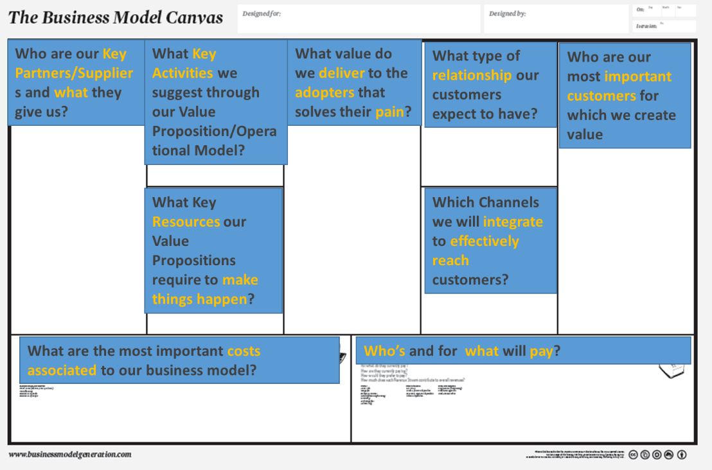

Figure 1. The Business Model Canvas Template

An example of a Business Model Canvas is the one used for/by UBER.

## Can the Business Model Canvas be wrong?

Many teams address the business model canvas like a cheklist. However, reality is that gaining deep insight on how those elements interact and how each component influences the other is the basis for making sharper decisions. Another issue, is that many teams form a business model canvas once and never look back. But the whole point of the tool is to draft many different versions of it until a business gets it right while it matures and considering what internal to the business or external factors have changed even in a small period of time. Another common mistake is that many teams don’t put in the BMC numbers, quantified metrics such as apart from who the customer is, how big is the customer base, or how much it costs to acquire a new customer. Finally, a business should list benefits rather than features that the customer receives. Finally, one common mistake is that because the business model canvas is built around the Value Proposition (center box) it is not problem/need centric. This means that it focuses on the value a product creates rather than the need in the market. But what if the problem is not accurately assessed…? Leaving out of the designed parameters the problem

|  |
| --- |
| **Resources:**   * [**Communicate your idea clearly and concisely**](https://leanstack.com/lean-canvas) |

makes the canvas … problematic. A later version of the Classic Canvas, the Lean Canvas developed by Ash Maurya tries to solve this issue.

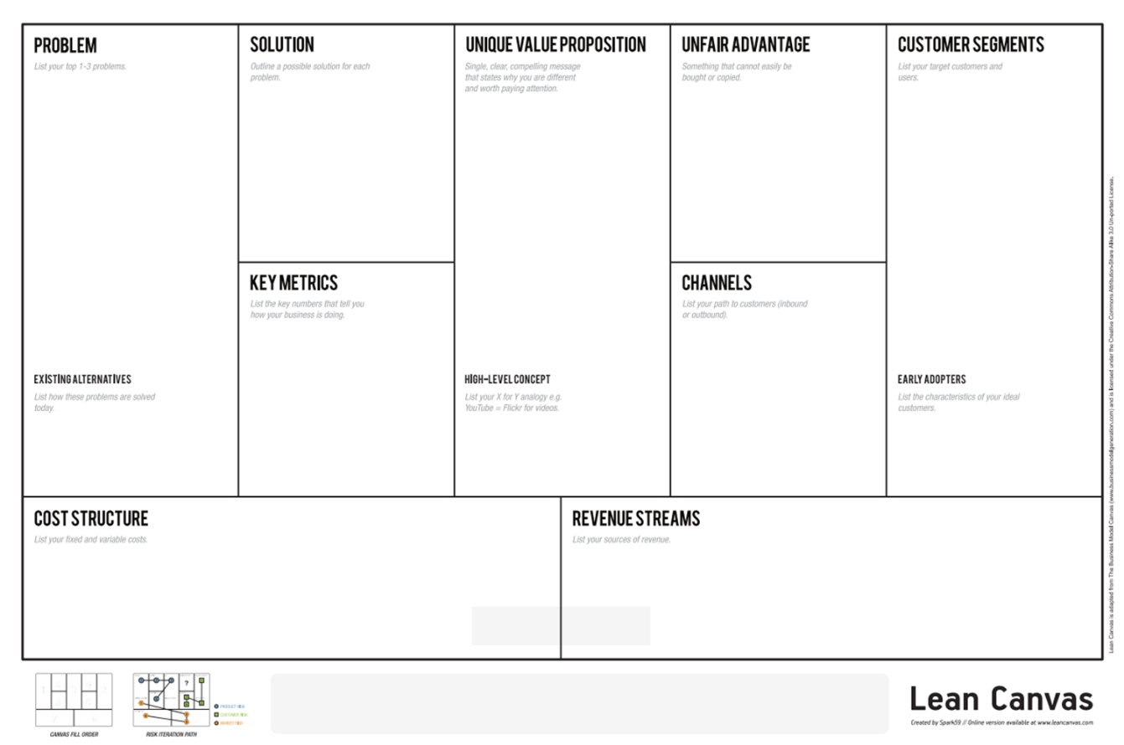

# Business Models for Social Enterprises

There are many different corporate forms that social enterprises can choose to operate with. The spectrum of social enterprises can span from charity to a commercial corporation and may take the following forms: charity operating a related business (non-profit), Not-for-Profit corporation with social purpose, business corporation with social purpose, business corporation donating to charity.

|  |
| --- |
| **Resources:**   * [**Social Purpose Institute**](https://socialpurpose.ca/) * [**Social Enterprise, B Corps and Public Benefit Corporations**](https://socialenterprise.us/resources/news/b-corps-public-benefit-corporations/) |

**1. Non-profit entities** are dependent upon third parties to fund all or part of their activities. The International Federation of the Red Cross & Red Crescent is a nonprofit entity – they rely on donations and grants to support their activities.

**2. Not-for-profit companies** are typically charitable organizations whose main purpose is to achieve their charitable goals, not to generate profit, although they may be profitable depending upon how the business is run. Often these organizations **generate income** by doing contract work that is done for the benefit of a beneficiary. For example, a company that provides free education to young children in central Asia, who is paid by the government, or a foundation, that has an interest in the end-result (ie, the government wants children educated but cannot deliver the services, so they hire a company to do it.)

**3. Social Benefit Enterprises** can be certified for their positive social mission, goals, and impact. In some countries (USA, EU) there is a special type of corporation (“certified B corp.” – the ‘B’ stands for ‘benefit’) which has special tax status and must have specific procedures and corporate governance.

**4. A Social Purpose Business** is a company that has embraced the goal of achieving social good on a **corporate** level and place it at the core of their operations, so it becomes the engine that powers the business and contributes to a better world.

**5-6.** **Businesses that ‘do good’** will either pledge a % of their resources towards **charitable/social activities** (H&M), or have a *business model* that devotes a particular portion of their *business* (including products/services/profits) towards positive **social change** (Toms)**.**

**7. Purely commercial enterprises** (ex: Starbucks), have a positive social impact (recycling used coffee grounds, for instance), which they typically use as a **marketing tool**, designed to either attract a particular type of customer, or encourage an image for the company, that will increase. sales. 

## A social enterprise

A social enterprise is a business that solves critical social or environmental problems i.e. has social or environmental objectives and is primarily concerned with serving those. Like traditional business social enterprises aim to make profit, but how they use those profits is what differentiates them i.e. reinvesting or donating them to create a positive social change. Social enterprises create employment for those marginalised, improve people’s life, provide training and employment opportunities, support communities and help the environment.

There are many kinds of social enterprise models; four of the most common are listed here.

* [Solar Sister](https://solarsister.org/)
* [The Garden Project](https://www.gardenproject.org/)
* [Toms](https://www.toms.com/)
* [OneArmenia](https://onearmenia.org/)
* [Statebags](https://statebags.com/)

Social Enterprises according to Social Enterprise UK[1]:

* Are business having a clear social or environmental mission that is set out in its governing documents.
* Are independent business and earn more than half of your income through trading (or are working towards this)
* controlled or owned in the interests of your social mission
* reinvest or give away at least half your profits or surpluses towards your social purpose
* are transparent about how you operate and the impact that you have

|  |  |
| --- | --- |
| **Case Study 1: UNIFORM**   |  | | --- | | **Resources:**   * [**How African-made brand UNIFORM is making ethical fashion accessible**](https://fashionista.com/2017/01/ethical-african-fashion-brand-uniform) * [**Uniform will be your new favorite ethical clothing brand**](https://www.papermag.com/uniform-ethical-fashion-brand-2057695295.html) * [**Chid Liberty: Building Fair-Trade Manufacturing in Liberia**](https://www.gsb.stanford.edu/insights/chid-liberty-building-fair-trade-manufacturing-liberia) |   UNIFORM was founded by the Liberian born Entrepreneur Child Liberty in Liberia, Africa for manufacturing clothes. UNIFORM provides: a) employment for disadvantaged communities (women in Ivory Coast) with the aim to raise the ***immediate*** standard of living for women by providing jobs and thus provide for their families *and* b) give school uniforms to their children, to raise the long-term standard of living (school uniforms = school attendance = better educated kids = better wages later).  **Case Study 2:**  **CAUSE**  Unfortunately, positive vision, goals, and mission are not enough to guarantee that a social enterprise will succeed. Many times, people wish to start a social enterprise but lack the skills, time, or experience to carry out their plan. CAUSE was a bar/pub that wanted to donate its profits to a social cause that was chosen by its patrons. But the founders did not have the time to work there full-time, or any experience in the restaurant industry. They relied completely on social media to bring in new customers and grow their business, and they over-estimated how much their customers would spend, and how often they would come. The lack of a viable business model meant they closed after 14 months, although the initial reaction from customers was very positive. |

Social Enterprises are also very vulnerable to any kind of ethical issues that might befall the company and/or its associates. Because many social enterprises are built by visionary individuals (who are often very charismatic), the enterprise is often tightly associated with the founder. If problems such as mismanagement or corruption arise, they must be confronted and corrected immediately in order to avoid contagion and damage to the company’s reputation.

|  |
| --- |
| **More Examples:**   * [Homeland](https://www.hdif.org/) * [Responsible Tourism in Caucasus](https://wander-lush.org/responsible-tourism-armenia-tips-onearmenia-interview/) * [OneArmenia](https://www.onearmenia.org/) * [Report Analysis of social enterprises in Armenia](https://yerevan.impacthub.net/report-analysis-social-enterprises/) * [Impact Hub Yerevan](https://yerevan.impacthub.net/) * [Peer Review on Social entrepreneurship to tackle unmet social challenges](https://www.google.com/search?q=social+enterprises+vulnerable+to+social+issues&rlz=1C5CHFA_enGR948GR948&oq=social+enterprises+vulnerable+to+social+issues&aqs=chrome..69i57.16972j0j7&sourceid=chrome&ie=UTF-8#:~:text=Peer%20Review%20on,eu%20%E2%80%BA%20social%20%E2%80%BA%20BlobServlet) * [CAUSE, Philanthropub Opening In Shaw, Will Donate Proceeds To Charity](https://www.huffpost.com/entry/cause-will-donate-proceed_n_1962084) * [Greg Mortenson goes on Today to apologize for Three Cups of Tea scandal](Greg%20Mortenson%20goes%20on%20Today%20to%20apologize%20for%20Three%20Cups%20of%20Tea%20scandal) |

# Market Segmentation

Minimum Viable Segment (MVS) is about focusing on a market segment of customers who share the same needs. This is critical since at the beginning, end users who have divergent needs may pull a business MVP to many different directions increasing the product requirements. The MVS needs to be small enough to dominate it before a business goes

|  |
| --- |
| **Resources:**   * [Don’t make the mistake of overlooking your Minimum Viable Segment](https://venturebeat.com/2013/06/03/minimum-viable-segment/) * [MVS achieving growth through smaller customer segements](https://marcinszelag.medium.com/minimum-viable-segment-mvs-achieving-growth-through-smaller-customer-segments-23323ae5cca1) |

|  |
| --- |
| **Resources:**   * [What is TAM SAM SOM? How to Calculate and Use It in Your Business](https://www.process.st/tam-sam-som/) * [TAM, SAM, and SOM: fundamental market size metrics](https://www.lean-case.com/tam-sam-som/?utm_source=CRM&utm_medium=email&utm_campaign=Backlinking&) * [Tam Sam Som Market Evaluations - Easily Explained](http://tamsamsom.blogspot.com/) |

for a lager segment. It is essential that a business goes through an iterative process of investigation i.e. through interviews to define the right market segment and test the business concept. If a business succeeds on getting the MVS acceptance, then the Segment is also Viable.

In order to build investor trust, it is essential to evaluate the feasibility of a product through accurate market size numbers. As a first steps a business need to determine the Total Addressable Market (TAM) which is the total market demand for a product or service. Usually, TAM is calculated in annual revenue or unit sales if 100% of available market is achieved. Next is Serviceable available market (SAM) which is a portion of TAM targeted and served by a company's products or services. In order to calculate SAM we estimate all the potential customers that could be the total market fit for your exact business/solution offering and multiply that by the average annual revenue of each customer in that market. The next smaller and more specific market dimension is the Serviceable Obtainable Market (SOM) which is the segment of your SAM that is within your reach and you can obtain. Last but not list, is Launchable Obtainable Market (LOM) a part of SOM you should target when launching and is populated by your Minimum Viable Segment.

## Customer Profiling

|  |
| --- |
| **Resources:**   * [Consumer Profile: Defining the ideal customer](https://www.thebalancesmb.com/consumer-profile-defining-the-ideal-customer-2296932) * [How to create an effective Customer Journey Map [Examples +Template]](https://blog.hubspot.com/service/customer-journey-map) * [The best way to map the customer journey: take a walk in their shoes](https://www.surveymonkey.com/curiosity/map-customer-journey-keep-customers-happy/) * [Customer Journey Mapping- Six steps to Creating the complete Customer journey maps](https://www.invespcro.com/blog/customer-journey-maps/) |

Projects often evolve from an idea and grow its features through the opinions of the founders, who may never be customers of the product. This may result to a product or a service that doesn’t meet customer expectations or needs. Customer profiling is a way to create a portrait of customers, to help a business make decisions concerning the design of a product or a service i.e. decide on the features that helps the customer achieve a goal more easily. It is a way for making customer-centric decisions considering the customer opinion. When creating a customer profile the critical information required for end users is their goals (why they interact), their tasks (what they will do when they interact), and the goals of the interaction.

## The Minimum Viable Product

|  |
| --- |
| **Resources:**   * [The Lean Startup Methodology](http://theleanstartup.com/principles) * [What is an MVP](https://leanstartup.co/what-is-an-mvp/) |

The MVP (Minimum Viable Product) is a most basic version of the product that a company wishes to launch. It includes a minimum set of attributes that can be viable as is in the market in order to begin the process of learning what the customers really need and how the product could best solve their problem. Because MVP is a minimum and also viable product it’s more manageable and can allow the maximum amount of [validated learning about customers](https://startuplessonslearned.blogspot.com/2009/04/validated-learning-about-customers.html) with the least effort.

## Market Fit

|  |
| --- |
| **Resources:**   * [12 Things about Product-Market Fit](https://a16z.com/2017/02/18/12-things-about-product-market-fit/) |

Market Fit or Product Market Fit is about identifying a good market to launch a product capable of satisfying that market. Many business believe their product fit the market, when it is actually don’t. A business needs to confirm that enough people are indeed willing to pay for a product before it can focus on other issues of strategic importance such as growth. To achieve this important milestone i.e., Product Market Fit, a lot of business angles need to focus on this such as sales, marketing, finance, business development. Signs that show the business has taken a good direction towards achieving Product Market Fit include both qualitative and quantitative metrics:

**Qualitative:**

* Word of mouth. (As Andreesen says, if your customers talk about your products with others, they effectively become your product’s sales reps.)
* Calls from the media or industry analysts come in much more frequently, and coverage of your product and company increases.

**Quantitative:**

* NPS score
* Churn rate
* Growth rate
* Market share

A company can claim that has achieved “market fit” when by using effective market positioning and distribution techniques can displace competitors. Signs of strong Product/Market Fit can be a faster product adoption that you initially serve or when your customers are as excited about your product as you.

1. Social Enterprise UK, <https://www.socialenterprise.org.uk/what-is-it-all-about/?su=t0>