CONNECT 2021-2024

Connecting universities-industry through smart entrepreneurial cooperation and competitive intelligence of students in Moldova, Georgia and Armenia

|  |  |
| --- | --- |
| Project Acronym: | CONNECT |
| Project Title: | Connecting universities-industry through smart entrepreneurial cooperation and competitive intelligence of students in Moldova, Georgia and Armenia |
| Project No: | 617393-EPP-1-2020-1-MD-EPPKA2-CBHE-JP |
| Funding Scheme: | ERASMUS+ |
| Coordinator: | Moldova State University  (MSU) |
| Project Duration: | 3 years (starting January 2021) |

**ADVANCED ACCELERATION MODULE**

**Raise of Funding and Governance**

|  |  |
| --- | --- |
| Work Package: | WP 2 |
| Lead Beneficiary: | Anthology Management LLC |
| Submission Date: | 16/09/2021 |
| Dissemination Level: | Public |

*The contents of this document are the sole responsibility of UNATC ”I.L.Caragiale” and can under no circumstances be regarded as reflecting the position of the European Union.*

**TRAINING MODULE ON**

**RAISE OF FUNDING AND GOVERNANCE**

The module: A training Module on Art/Acting education, for trainers, early stage and incorporated startups and teachers to use in non-formal education settings.

Contributors and Editors: Adriane Thrash, Argyrios Spyridis, Paraskevi Gkiourka

Project: CONNECT - Connecting universities-industry through smart entrepreneurial cooperation and competitive intelligence of students in Moldova, Georgia and Armenia

Funded by: Erasmus+ Programme

Partners: Anthology Management

DISCLAIMER

The European Commission support for the production of this publication does not constitute an endorsement of the contents which reflects the views only of the authors, and the Commission cannot be held responsible for any use which may be made of the information contained therein.

Use of the content for non commercial use is authorised, provided the source is acknowledged

CONNECT Project 617393-EPP-1-2020-1-MD-EPPKA2-CBHE-JP

Introduction to Raise of Funding and Governance

Funding your new business, no matter if it is a startup or not, is always a challenge for founders with no experience discovering on the way the complexity of financing their project. Less developed ecosystems make the situation even more difficult for high-risk new ventures as they fail to adapt to the different requirements in exploring or evaluating funding options. In developing startup ecosystems early-stage independent investors more risk-averse while institutional investors are less accessible. In that case the remaining options left for funding a project are banks, available grants, government subsidies and someone’s family. It is important to understand that the presence of a combination including adequate funding alternatives and early-stage investment culture can shape the dynamics of local economies and the ecosystem itself.

Technological and industrial infrastructures also play an important role in the funding options. Eg. countries with high concentrations of developers and technology companies are more likely to eventually attract investors and offer more financing alternatives for the startups and SME’s operating in those environments. In a way it’s a self-propelled condition that generates more of itself. This trend though was broken partially in certain ecosystems as the rise in demand for talent brought higher salaries and costs overall. The need to source talent at lower cost markets along with local efforts to induce local ecosystem development converged to create new dynamics in the global startup scene.

The “type” or source of money needed to finance startup steps are not the same for all types of ventures and at all stages of their lifecycle. Getting money from friends, an early-stage investor, an institutional investor, public money or a grant may look like different alternatives before the eyes of the average founder, but the options are more limited in real life due to a number of reasons. Startup and Small Business founders must understand first the conditions that decision makers operating in funding entities account before they examine an investment case. The same is true for making accurate financial estimates about the amounts and personal commitment that is required before they launch a campaign to fund their project.

Startup Types and Funding

Startups examined by institutional investors are usually a) Buyble b) Scalable and Large Company Startups according to the “6 types of startups” classification by Silicon Valley veteran Steve Blank writing in Xconomy back in 2011. The reason for that has to do with the following:

1. “Exit” orientation
2. Market size addressed
3. Expected company valuations at “exit”

The rest 4 types are not considered attractive by institutional investors who might not like to take risks where there is not “enough potential” for super-profits that justify the ad-venture. Out of those companies Small Businesses that grow in a viable way, can attract different kinds of investors but it is a rarer phenomenon. In the case of those 4 types of companies’ other sources of funding may be more appropriate for their operations like grants, public subsidies, bank loans or a merger at some point down the road. Investable startups on the other hand have a more demanding process to go through that leads to higher mortality rates than other more conventional types. This is due to the high-ambitions plan combined with proportional needs for resources that leads to a very intense period where there is not enough (most of the times not at all) liquidity to fuel the founders’ dreams. That period/stage is also called “the valley of death” due to the curve in the negative cash flow as show below

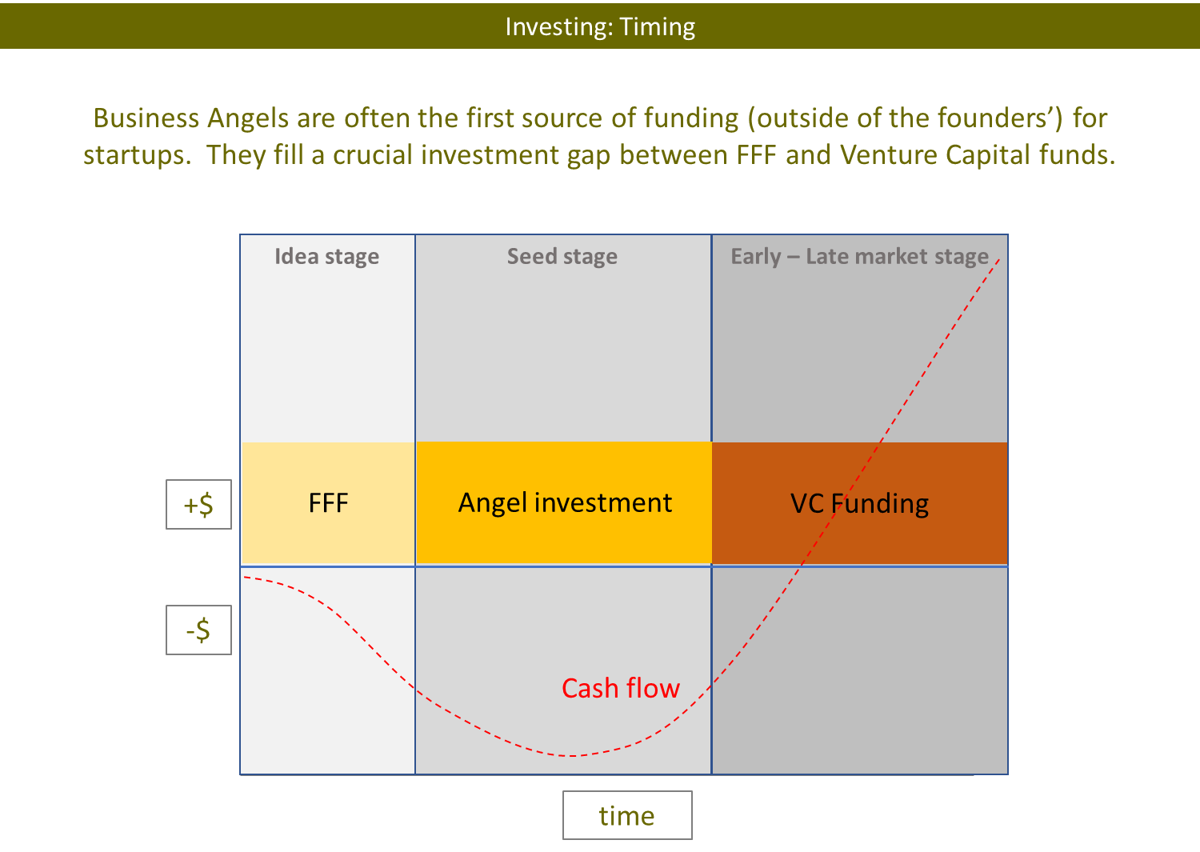

Funding and Startup Life-Cycle

Depending on the stage of their lifecycle, startups interested in looking to funding sources other than banks may or may not have access to capital. When in an “Idea Stage” or a having “Power Point Startup” status, it is almost impossible to get funding because ideas simply don’t get funded… Inexperienced startup founders who believe strongly that their “amazing idea” will lead them and their investors to some type of global success will lose a lot of valuable time to discover that investors do not fund idea-stage projects due to the extreme risk (at that stage).

At this early point, the founder or the founders’ team should procced with “bootstrapping” and self-funding for as much as possible even if they must finance a working (or semi-complete) prototype of their new product or service. By the term “bootstrapping” we mean growing your business with little or no outside investment. It also means relying on your own savings and revenue to operate and grow. Generally speaking, bootstrapping helps minimize somewhat the execution risk of manufacturing and help for a better case for the three FFF’s (Friends Family and Fools) that follow on the investing life-cycle as a source of very early stage funding.

As a startup heads closer to some form of alpha or beta testing or product launch, the chances for funding from institutional investors increase and exiting the valley of death can be a more realistic expectation. Funding entities like Business Angels and a few Angel Funds or Accelerator VC’s can be within the reach of a fundraising campaign. Business Angels are high net worth individuals who take very high risk stakes with early stage ventures in exchange for equity towards their investment. Their capital infusion is usually in the form of convertible notes, S.A.F.E agreements, warrants or straight equity.

Early-stage investors will assess a few factors to decide if they will go ahead with placing their bet with the startup or not. These are mainly:

* + - 1. The strength of the team

1. The size of the market
2. Competitive Advantage and Business Model
3. Competition
4. The prototype status
5. Time to market
6. Funding needs as derived from the business plan.
7. Friction Points

In the next phase, after some traction from paying customers (preferably not just users) Venture Capital Funds (VC’s) can finance bigger amounts of money than previous entities but also contribute with additional support like networking, know how, etc. VC’s funding capacity ranges from pre-seed, to seed and all the way to Series A, B, C, D etc. funding rounds.

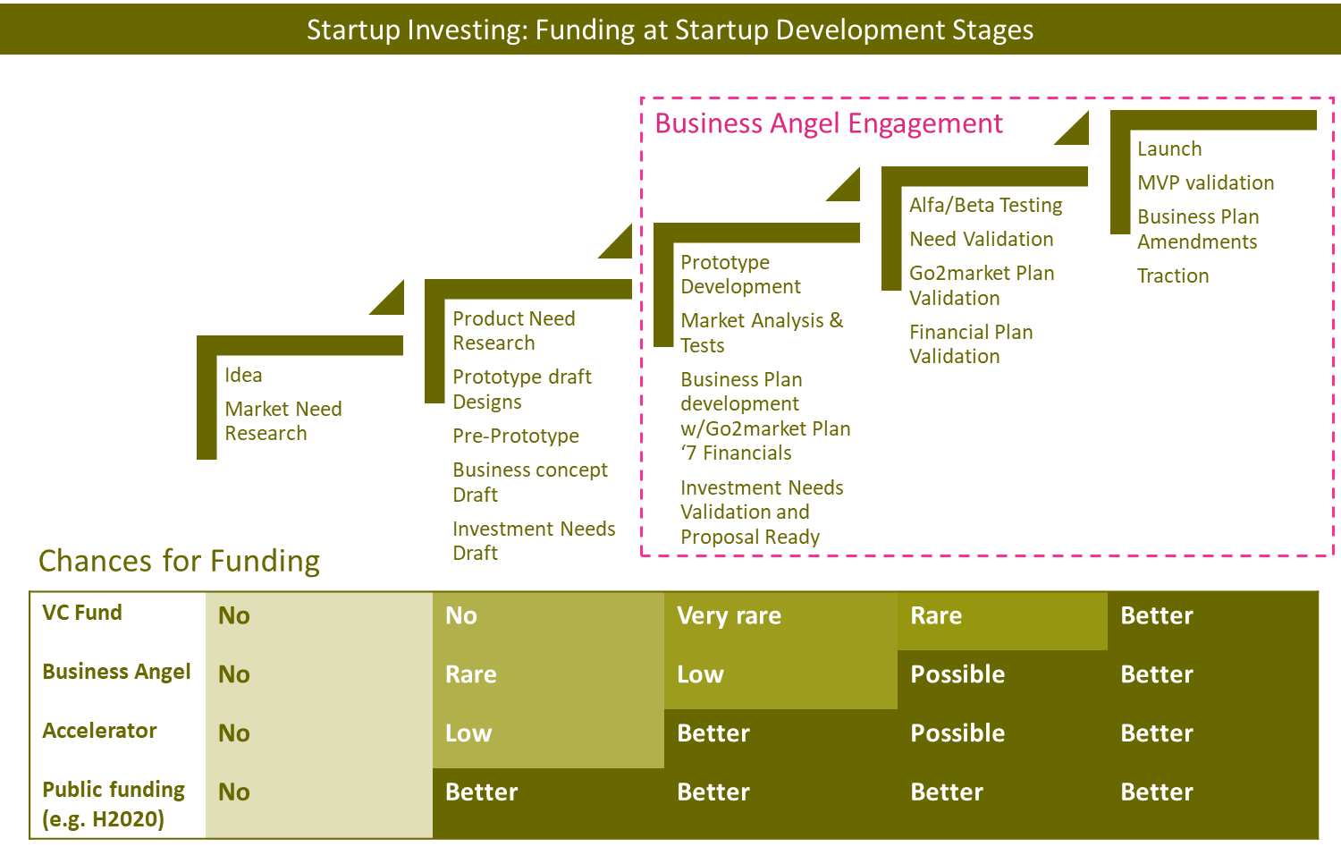

The amounts raised by investing entities vary by stage or the type of the entity, therefore a startup should direct its effort wisely as to “match phase with raise” as well as to meet its financing needs with the appropriate amounts and timeframe. Understanding the conditions of the startup’s lifecycle and its status can be vital as it can save the founders from wasting time knocking the wrong doors or looking for wrong things at the wrong time.

Εικόνα που περιέχει κείμενο

Περιγραφή που δημιουργήθηκε αυτόματα

Part of a Raise of Funding campaign are two interrelated things: the value of the startup and the funding need. Both figures are dynamic and typically increase as the startup moves ahead with the implementation of its plan. In that token, more resources are needed to cover rapid market expansion needs and because of the progress achieved, the value of the company also changes. The mentioned figures are elements of a more complex situation where the company must balance its needs with the desired funding options that are appropriate for the execution of the plan and the stakes of its shareholders.

The “investment ask” or Funding Need is the amount of money a startup can request from candidate investors if the outside investment is the path selected to facilitate the need for the desired liquidity. The “Investment Ask” is usually part of a structured investment proposal describing the among other things the business opportunity, the proposed implementation steps requiring capital infusion and the terms of the deal.

The investment amount you requested is contrasted with the equity offered in exchange and all these under a specific valuation of the company which at this point is called “pre-money valuation”. For an example if as startup asks for an investment of X.000 euros, it needs to suggest what % of shares it offers in exchange. But how is that calculated? Here is an example:

“Smart Doors” a startup that developed an innovative solution for home security is looking for 150.000 euros to finance their first steps in the market. The company in order to calculate the amount will need to value the company first. But what determines the value of a startup and how can we assume any especially in the early steps where no or small amounts of sales are generated?

According to Seedcamp “*the the biggest determinant of your startup’s value are the market forces of the industry & sector in which it plays, which include the balance (or imbalance) between demand and supply of money, the recency and size of recent exits, the willingness for an investor to pay a premium to get into a deal, and the level of desperation of the entrepreneur looking for money”.*

The practice estimating the value of a company is a called valuation. Startup valuations typically employ/combine different methods of mathematical and aspirational data: These methods are: Venture capital valuation method, Berkus method, Valuation by multiples method, Discounted Cash Flow Model, and more.

For the shake of the example let’s assume that the value of the startup before the deal with an investor was calculated at 750.000 euros. That is called “Pre-money valuation”. If the candidate investor agrees to offer 150.000 euros under the suggested valuation then the equity offered back will be calculated on the basis of “Post-Money Valuation” which is: 750.000+150.000 = 900.000 euros, therefore the investor will get 150.000/900.000 = 16,67% of the company’s shares. But what happens to the equity of the original shareholders? Well they get “diluted” proportionally therefore their stake in the company will be to 83,33% (from 100%). Shareholder dilution can increase as more investments are attracted so its important for founders to include that calculation in their plans related to the governance of the company and their exit scenarios.

Valuations are elements of the investment negotiation during which the investors may also suggest on prerequisites that could de-risk their bet as well as the investment vehicles like*:

* Straight equity: basically, money for x amount of shares
* Convertible Loan: A loan that if unpaid it converts to equity under specific terms
* S.A.F.E. : Acronym for Simple Agreement for Future equity where a more simple and cheaper process compared to a Convertible Note is followed where the amount offered is converted in the future to shares
* In kind investment: The investor offers its services in a in-kind (non-monetary) investment that are valued under a specific agreement.

*More on the above will be presented later.

The Cap Table

The structure of different shareholders engaging in a startup during repetitive investing cycles is depicted in the Cap Table. The Cap Table provides an analysis of a company's percentages of ownership, equity dilution, and value for each equity in each round of investment by founders, investors, and other owners. Over time investors get diluted when additional capital is raised and if they don’t defend their share by re-investing. The diluted % of shares may (or may not) have higher monetary value based on the fluctuation of the company’s valuation over time. The cap table will not only show shares fragmentation but also help in making assumptions about equity distribution versus funding but the present and future control of the company by its shareholders.



Due to the complexity of decision parameters in such cases, startup founders with no prior record of buying or selling companies should look for the help of experienced advisors before they engage in a Raise of Funding process and sign any deal.

Pitching to investors

Pitching your business concept is a synthesis of elements figured out and explored in your validation and business plan; An alternative, more conventional way is to describe pitching is by the word “presenting”. The difference is that the content of pitching is very condensed and also very simple in digestion when delivered in a fast engagement, usually with early-stage investors or other stakeholders.

The term pitching has a sports origin and is described in Wikipedia as “In baseball, the pitcher is the player who pitches the baseball from the pitcher's mound toward the catcher to begin each play, with the goal of retiring a batter, who attempts to either make contact with the pitched ball or draw a walk”.

With “pitching” as startup can introduce a business idea in a limited amount time – from a few seconds to a few minutes with the help (or without) of a presentation to underline the speech. The main objective of a pitch is get support.

You shouldn’t randomly deliver/communicate the content of your pitch. All its elements should be able to pass clear messages about the validated need and market size and how those point to a notable business opportunity.

Investors of buyable or scalable startups like to see big (billion-euro size) markets that are growing and allow space for new business approaches or product/service solutions. Investors in all kinds of startups know that you cannot conquer the world today but if a startup team is ready to deliver and have what it takes (investment readiness), they hope for a chunk of that market pie and make a huge profit in the case they are looking for some exit originally. It is important to show that a startup team pitching has all or most of what it takes as investors and stakeholders trust will them the necessary support.

There are different types of pitching based on the **audience**:

1-Investors: You pitch to raise funding

2-Customers: You pitch for feedback

3-Sales: You pitch to introduce your product/service and ultimately sale

4-Employees: you pitch to recruit or motivate employees

5-Partners: you pitch to recruit or motivate partners

6-Competitors: You pitch to explore synergies

Exploring more the **investors pitching** and specifically in relationship to time available (duration) and conditions, we identify the following types:

* One-sentence pitch (‘value proposition’)
* 60-second pitch (‘elevator’)
* Competition pitch used in events (3-8 minutes)
* Investment pitch (20-40 minutes)

In any of the above cases - regardless of their duration – the pitching startup presents an opportunity via its business case. But what is defined as an “opportunity”? Well, that differs depending on who’s asking… here are a few examples:

**Small business:** Maybe interested on the collective skillsets and expertise of the founders of a lifestyle startup, another small business, or just a local market reach that suggests favorable opportunity costs. in the case of an such investment the investor gains lower production costs, lower access to market costs or to a more efficient team.

**A big business or corporation:** Maybe interested on the technology developed from a buyable startup, or just a local market reach that suggests favorable opportunity costs.

**Investor of Small Businesses:** Maybe interested on the possibility to be part of a sustainable business that will distribute dividends in a few years and offset the investment through that.

**An Investor of Buyable or Scalable Startups:** Looking for big markets and profits via an “exit” down the road at a much higher valuation that will deliver profits. Not interested on dividends as much but to a return of 3X-30X the amount invested. Usually, this type of investor will place more bets as to spread the risk stemming from such high expectations hoping that 1-2 out of the10 invested companies in the portfolio will offset the losses and account for the desired profit from such a practice.

Pitching at all cases must show market size (the bigger the better) as to justify the total potential in the market addressed. The presenting startup must also show the competition in that market, direct or indirect and the analyze it through easy-to-understand comparisons in order to justify awareness of the market gaps and the opportunities created due to the combination of the displayed competitive advantage and the underserved needs.

The go2market plan (your early steps in the target market) related launch to business development, getting the first customers, marketing promotion, pricing, legal requirements, relationship with market players, budget, human capital needed, are also presented. The logic of the plan should be supported with the main figures of 3-5year projections that are calculated in A financial plan (Revenues, EBITDA, Cash flow) that will justify the “Investment Ask”; in other words, *“why you need the money you ask for”*.

The presentation should be supplemented by a timeline of the key milestones in the past-present-future continuum and the team that will deliver the plan, their roles, experience, and commitments. Knowing well the material presented and having done the homework of profiling the audience, is imperative for the success of pitching which has one goal; the “next date” … until there is no need for another meeting.

The pitching-deck

The pitching-deck is you tool to accompany your speech. Depending on the communication conditions and sequence it can include several slides that usually depict the critical elements of your business plan and presented in the following (or similar) order:

1. Company Overview
2. Mission/Vision of the Company
3. The Team
4. The Problem
5. The Solution
6. The Market Opportunity
7. The Product
8. The Customers
9. The Technology
10. The Competition
11. Traction
12. Business Model
13. The Go2Market Plan
14. Financials
15. The Ask

There can be different number of slides more or less than the above depending on the type of the pitch. Some types of investor-decks can be more analytical and accompanied with more supporting documents when sent to funding entities like spreadsheets of your Financial Plan, Gantt charts, Executive Summaries, Investment Proposals etc. In that case an exchange of different documents may follow depending on the origin of communication and the maturity of meeting conditions

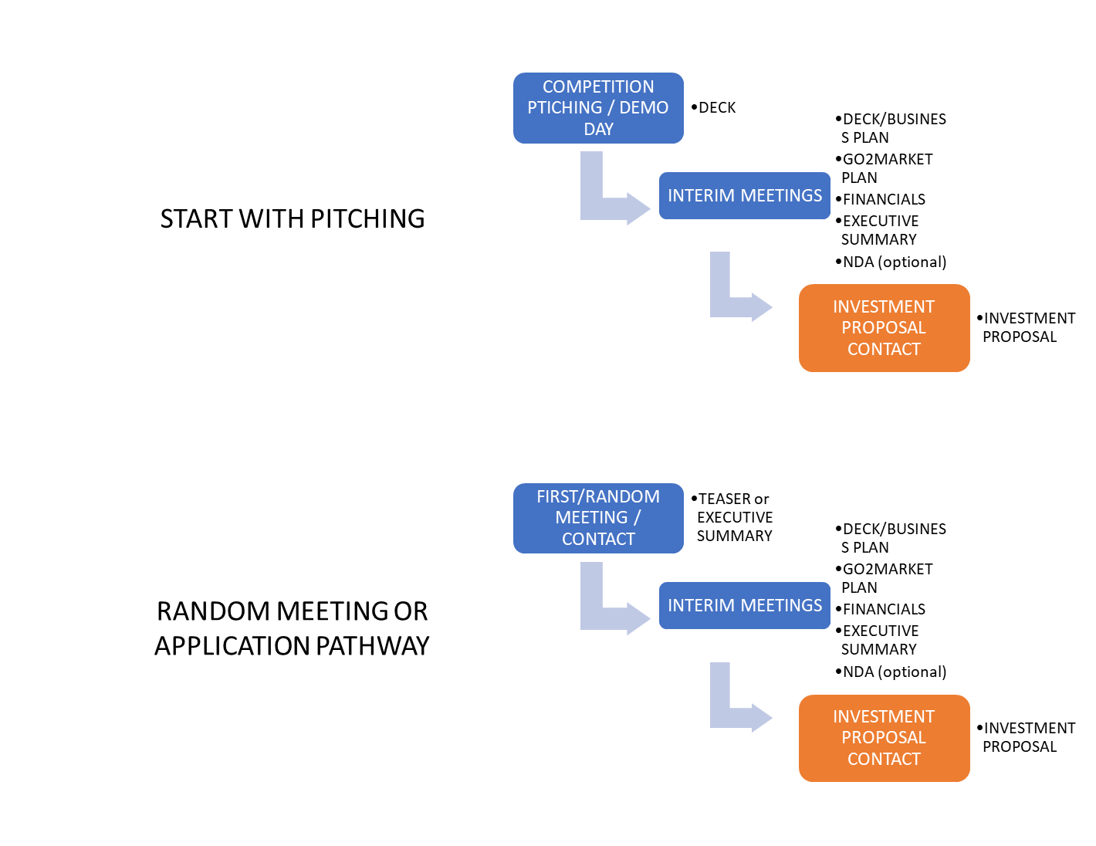

Founders Agreements: Paving the grounds for investment and startup governance

Before a startup team gets an official bond via the Articles of Incorporation it is important for company’s founders to have an agreement among themselves even before creating their entity. That agreement can result as a product of their talks at the early stages of formation. Having honest and clear definitions of goals, aspirations and type of commitments, individual founders can decrease the likelihood of undesirable complexities that many times end to the dissolution of the startup before even it begins.

A Founders’ Agreement is a basically a contract that a startups founders will enter that provides the basics of governance for their business, the rights and responsibilities, liabilities, and obligations of each one of them. The Founder’s agreement sets the grounds for the core team to understand the business relationships within as well as the consensus required to take certain decisions based on challenges like:

* Roles and Equity Distribution
* Adding team members
* Dealing with their shares
* Confidentiality
* Intellectual property
* Dealing with investors

In a way a founder’s agreement resembles the Shareholder Agreement while the later requires a company formation and is way more analytical and binding. The following questions can provide answers that can become elements of the Founders Agreement:

* What goal the founders collectively share for the start-up?
* What are examples of those goals that are commonly shared?
* What are our respective timelines for these goals?
* Who gets what percentage of the startup upon formation?
* What will we each founder contribute to the company? (in-kind, duties, money, networking, experience).
* Is the percentage of ownership shares subject to vesting?
* How are day-to-day or strategic decisions made? (e.g., Voting rules etc)
* Salaries (if any) are the founders entitled to?
* What happens if a founder leaves on his/her own decision and what happens to the shares?
* What happens if a founder does not perform as expected
* Under what circumstances can a founder be removed as an employee of
* the business?
* How a negotiation with an investors is decided?

After incorporation the Founders Agreement should be replaced with a Shareholders Agreement that elaborates more into things that affect the shareholders rights and responsibilities. The rest of the topics that affect governance should be explained in the Articles of Incorporation and other documents like Job Descriptions, Management Contracts and other manuals.

Investment Processes and Documents

The process of Raise of Funding for a startup can be a complex one and requires a good understanding of the basic parameters and players involved. In any startup deal usually there are two types of players involved: The recipient (of the investment) party and the investors. The first are considered by many as “One Shot” like first-time entrepreneurs’, early employees or even common shareholders. Their capital is concentrated in their “one company” or project. Typically lack significant personal wealth, don’t have much economic stamina or experience. The second are also called “Repeat Players” like investors, accelerators and other entities are wealthy, and they’ve played the investment-deal game many, many times; especially the large repeat players, who like that risk and are more “failure-proof”

Early-stage investors engage either before a startup is incorporated or after that. In the case of an investor investing in a startup before that is incorporated the engagement takes place by reserving their rights over acquiring/buying shares at some point in the near future via an agreement. An investor can acquire/buy shares at nominal price or market value with a Stock purchase agreement (SPA) that is exercised at the time of purchase so that requires that the startup is finally incorporated. Before that happens other types of documents like a S.A.F.E. (Simple Agreement for Future Equity), a Warrant or Convertible Note can be utilized as to document the agreed commitment terms.

More analytically the following are the typical ways that an agreement between a startup and an investing entity can be facilitated:

**Straight Equity:** It involves direct exchange of company shares for an agreed upon investment i.e., €20.000 for 3% of the company’s shares. The investor gets his/her shares after buying them at a specified price/share rate.

* Time of investment payment: Present
* Time of shares acquisition: Present
* Time of share price fixing : Present

**Combined In-kind and Monetary Investment:** It accounts in-kind and monetary contributions together for a total % of equity. Equity materializes upon money contribution or later, using convertible notes, warrants or other investment vehicles

* Time of investment payment: Present
* Time of shares acquisition: Present
* Time of share price fixing : Present

**Convertible Note (or C-Note):** a form of short-term debt that converts into equity, typically in conjunction with a future financing round; practically speaking, the investor would be loaning money to a startup and instead of a return in the form of principal plus interest, the investor would receive equity in the company. Typically, the investor buys at a discounted price/share and a valuation cap

Eg. Loan of € 20.000 for a period of 3 years with 4% interest. Conversion after maturity date with a 20% discount and a 2.000.000 valuation cap (the maximum agreed valuation)

* Time of investment payment: Present
* Time of shares acquisition: Future
* Time of share price fixing : Present/Future

**Warrant:** A stock warrant represents the right to purchase a company's stock at a specific price and at a specific date. A stock warrant is issued directly by a company to an investor. A call warrant represents a specific number of shares that can be purchased from the issuer at a specific price, on or before a certain date mentioned in the warrant. A put warrant on the other hand, represents a certain amount of equity that can be sold back to the issuer at a specified price, on or before a stated date. Warrants are classified by their exercise style as applied in different ecosystems. An American warrant can be exercised anytime before or on the stated expiration date, while a European warrant can be exercised only on the expiration date.

A warrant holder has no voting, shareholder, or dividend rights and gets no say in the functioning of the company, even though they are affected by their decisions and policies.

* Time of investment payment: Future
* Time of shares acquisition: Future
* Time of share price fixing : Present

S.A.F.E. : (simple agreement for future equity) is an agreement between an investor and a company that provides rights to the investor for future equity in the company similar to a warrant, except without determining a specific price per share at the time of the initial investment.

Types of S.A.F.E.s

* Cap, no discount
* Discount, no cap
* Cap and discount
* no cap, no discount

S.A.F.E.’s are used a lot in the United States and especially in California. Other countries also use SAFE’s like India. In a way a S.A.F.E. is a “founder/investor friendly” type of an agreement that minimizes legal costs at the time of the investment. Unlike the a convertible note where the tax period will begin with its purchase the holding period of a S.A.F.E will be retroactive, dating back to the time it had been issued.

* Time of investment payment: Present
* Time of shares acquisition: Future
* Time of share price fixing: Future

Before an agreement between the startup and the investing entity the later will offer a Term-sheet describing the terms of the agreement with enough detail. The Term-sheet is usually a non-binding document and engaged parties may choose to withdraw from the deal before it concludes. As it can be a complicated document legal/expert advice is highly suggested for the non-expert party.

The contents of the Term-sheet may include:

* Liquidation Preferences: Order by which funds a returned to investors upon a liquidity event
* Veto Rights and mechanism of exercise: Basically, the right to stop a decision/action
* Voting Rights: Grouping of stockholders, typically preferred stock as one group and common stock as another group, and their right to vote on core items as defined in the term sheet.
* Anti Dilution: Protects investors from dilution resulting from later issues of stock
* Right of First Refusal/Right of Co-Sale (Take-Me-Along): Defines the right of an investor to buy or sell shares in the future prior to an offer going out to another party.
* Drag Along rights: A right that enables a subset of shareholders to force all other shareholders to agree to the sale of the company.
* Tag Along rights: A right that enables a subset of shareholders to sell their stock along with other shareholders to selling theirs
* Redemption Rights: A feature of preferred stock that allows investors to require the company to repurchase their shares after a specified period of time.
* Amount Raised: Total amount raised to date.
* Price Per Share: Price of each share.
* Pre-Money Valuation: Value of the company before investment.
* Capitalization: All company’s shares multiplied by share price.
* Dividends: how they profits distribution is dealt with
* Founders/Employees Vesting: Companies and Investors often use vesting to encourage you to stay longer at the company and/or perform well so you can earn an award or discourage you from leaving the company early
* Conditions to closing: Tasks that must be fulfilled before the deal agreement is closed.
* Right to Participate Pro Rata in Future Rounds: An investor’s right to continue to participate in future rounds so they can maintain their percentage ownership.
* Matters Requiring Investor / Director (BoD) Approval: Identifies critical business decisions that would require consent from the investor representative on the Board of Directors.
* Non-Competition and Non-Solicitation Agreements: Neither party is allowed to enter into or start a similar business.
* Non-Disclosure and Developments Agreement: Agreement to not pass along confidential information to an external party about the business or its products or services.
* Employee Stock Options: A security which gives the employee the right to purchase company stock at a set price for a fixed period of time. Usually connected/associated with a Stock Option Pool allocated in the Cap Table
* No Shop/Confidentiality: Requires business not to solicit any offer of an investment in the company by a party other than the venture capital investor for a certain period.

**Videos**

Seed Funding for Startups: How to raise venture capital as an entrepreneur. Duration. 11:00

<https://www.youtube.com/watch?v=4RAs9Y5wwDo>

Startup Funding Explained. Duration 9:00

<https://www.youtube.com/watch?v=677ZtSMr4-4>

How to Pitch your Startup in 3 Minutes. Duration: 5:00

<https://www.youtube.com/watch?v=XWRtG_PDRik>

How to Pitch Your Startup. Duration 27:00

<https://www.ycombinator.com/library/6q-how-to-pitch-your-startup>

Dragons fight back tears after powerful pitch. Duration: 14:00

<https://www.youtube.com/watch?v=YzyVgimV6kM>

Dragons' Den 2012 - Zapper.co.uk secures record £250,000 investment. Duration: 14:00

<https://www.youtube.com/watch?v=s8d5wxGEGc8>

**Suggested Readings**

Mastering the VC Game, Author: Jeff Bussgang

Venture Deals: Be Smarter Than Your Lawyer and Venture Capitalist, Authors: Brad Feld and Jason Mendelson

Startup CEO, Author: Matt Blumberg

Founders at Work: Stories of Startups' Early Days, Author: Jessica Livingston, Publisher: Apress

Who: The A Method for Hiring, Authors: By Geoff Smart and Randy Street

The Five Dysfunctions of a Team, Author: Patrick Lencioni

Differences Between an Angel Investor and a Venture Capitalist: https://www.business.com/articles/angel-investors-vs-venture-capitalists/

Types of Corporations and How to Incorporate Your Startup: <https://www.svb.com/blogs/chris-behrens/types-of-corporation-startup#>

What Makes a Strong Startup CEO: <https://www.nfx.com/post/strong-startup-ceo/>