CONNECT 2021-2024

Connecting universities-industry through smart entrepreneurial cooperation and competitive intelligence of students in Moldova, Georgia and Armenia

|  |  |
| --- | --- |
| Project Acronym: | CONNECT |
| Project Title: | Connecting universities-industry through smart entrepreneurial cooperation and competitive intelligence of students in Moldova, Georgia and Armenia |
| Project No: | 617393-EPP-1-2020-1-MD-EPPKA2-CBHE-JP |
| Funding Scheme: | ERASMUS+ |
| Coordinator: | Moldova State University  (MSU) |
| Project Duration: | 3 years (starting January 2021) |

**EARLY ACCELERATION MODULE**

**Startup types &The Mentor-Mentee relationship building**

|  |  |
| --- | --- |
| Work Package: | WP 2 |
| Lead Beneficiary: | Anthology Management LLC |
| Submission Date: | 16/09/2021 |
| Dissemination Level: | Public |

*The contents of this document are the sole responsibility of UNATC ”I.L.Caragiale” and can under no circumstances be regarded as reflecting the position of the European Union.*

**TRAINING MODULE ON STARTUP TYPES &THE MENTOR-MENTEE RELATIONSHIP BUILDING**

The module: A training Module on Art/Acting education, for trainers, early stage and incorporated startups and teachers to use in non-formal education settings.

Contributors and Editors: Adriane Thrash, Argyrios Spyridis, Paraskevi Gkiourka

Project: CONNECT - Connecting universities-industry through smart entrepreneurial cooperation and competitive intelligence of students in Moldova, Georgia and Armenia

Funded by: Erasmus+ Programme

Partners: Anthology Management

DISCLAIMER

The European Commission support for the production of this publication does not constitute an endorsement of the contents which reflects the views only of the authors, and the Commission cannot be held responsible for any use which may be made of the information contained therein.

Use of the content for non commercial use is authorised, provided the source is acknowledged

CONNECT Project 617393-EPP-1-2020-1-MD-EPPKA2-CBHE-JP

Startup Needs

A startup is a basically a set of conditions surrounding a team working on an entrepreneurial concept/prototype or very early-stage company, usually less than 5 years old. The term startup according to Investopedia refers to “a company in the first stages of operations. Startups are founded by one or more entrepreneurs who want to develop a product or service for which they believe there is demand. These companies generally start with high costs and limited revenue, which is why they look for capital from a variety of sources such as venture capitalists”. ( <https://www.investopedia.com/terms/s/startup.asp> )

Other perspectives of de-characterizing a startup company from its “early status” are the following:

* Ability to buy other companies
* When you are no longer a high-risk stake for investors
* When you exceed revenues of $300-500 M
* When your brand is broadly recognized

In the above cases you might stop be seen as a “startup”.

Startups are ventures that are focused on a single solution which hypothetically meets more efficiently a market need. Their business model is typically a work in progress, and they lack adequate capital to launch their business. Startups begin with very limited resources and many times are “running on fumes” in their effort to validate their product and implement the necessary steps to bring it to the hands of their customers. Although most of the startups are looking for an “exit” by selling their company, fewer are investable and even fewer will make it.

Due to absence of common sense, a real need for the suggested solution, the necessary experience, and resources to implement it, startup projects remain unfulfilled dreams or fail miserably. Startup founders are most of the times “in love” with their unique idea and miss the answers needed to validate their certainty before its already late.

A good example of what is a startup idea is shown below:

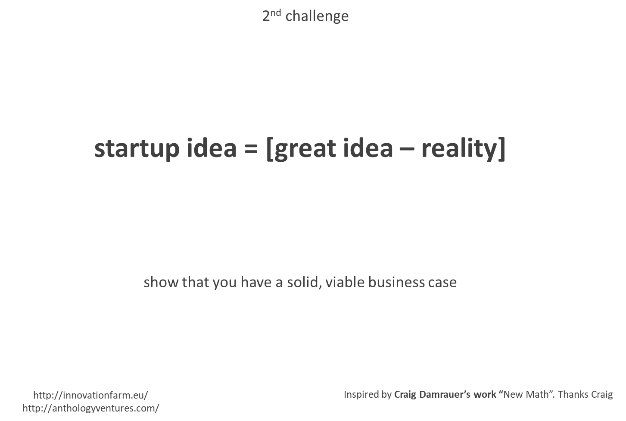

Most of the startups die during their first few of years of operations. This first period of business life where there is limited funding availability and doubtful market acceptance for their early product is called “graveyard” or “valley of death” and is accompanied with high mortality rates for the startups who enter.

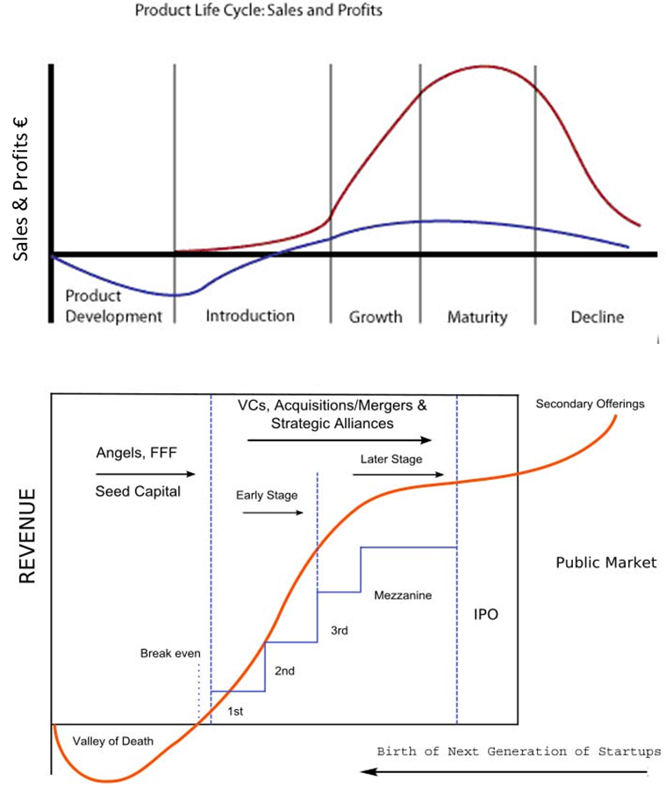

According to Steve Blank a Silicon Valley guru in his writing in Xconomy there are 6 types of startups:

- The Lifestyle Startup: The founders work to live, self-employed based in their own skills. Examples: Independent web developer, graphic designer, consultant.

- Small businesses, usually family owned and run: Working very hard like any other Silicon Valley entrepreneur, business not designed to scale but feed the family. They can be very profitable if successful.

- Silicon Valley-type startups / scalable startups: Are a small fraction of the six types of startups, but due to their astonishing returns and valuations (or better expectations) can attract all the risk capital from VC Funds, Corporate Funds and Companies.

- Startups designed to be quickly sold to other companies for amounts between $5M to 50M e.g. due to their tech and flipped.

- Large company startups. Dew to evolution in customer preferences, new technologies, legislation, new types of competitors, etc., disruptive innovation requires from large companies to drastically differentiate thus creating entirely new products sold to new customers in new markets.

- Social startups — Their founders form them around some charitable character. Probably the opposite state of scalable startups, as their objective is to make the world a better place and not build wealth for their founders.

<https://steveblank.com/2011/09/01/why-governments-don%E2%80%99t-get-startups/>

<https://www.youtube.com/watch?time_continue=4&v=CIA9ikESXYI&feature=emb_logo>

The early startup boom started in 1995 leading to the “Dot.Com bubble” in 2002 with companies loosing around 78% of their market value and less than half of them surviving the burst. That period was characterized from the early e-commerce and ISP/Telecom spreading across the world but mainly in the US allowing for “gravity-free” trade. After 2005, a follow-on development of startup ecosystems around the world led by Silicon Valley companies and funding entities, introduced a much broader spectrum of startups offering solutions across all market sectors.

Today according to Statista, the three mostly Populus tech-sectors that concentrate the largest number of startup are FinTech, Life Sciences/Healthcare and Artificial Intelligence accounting for about 20% of a very broad range of new ventures. In 2021 the Covid 19 pandemic along with the intensification of climate change attracted founders and investors interest in:

* Advances in gene delivery, especially for infectious diseases
* Disaster Preparedness
* Climate Change Tech
* Sustainable Materials to Replace Plastic
* Future of work

No matter the type of startup, technology plays a catalytic if not imperative role to most of them, therefore the degree of tech development or adoption can determine to a great extend the competitiveness of an early-stage venture. From a life-style startup, a small business to a buyable or scalable entity, founders’ ability to integrate efficiently technology in the solution and/or operations is critical.

A startup journey starts small with very limited resources therefore the founders’ ability to operate and implement their plan to excel in what they want is both very difficult and rare. Most of the startups - regardless of type - will die during the first few years either due to inability to understand the market or because they lack the necessary resources. Like any challenging and long trip, a startup team needs preparation, know-how and resources. Imagine having to go to an expedition to climb a very high mountain under extreme conditions that you don’t know or without even haven’t climbed mountains before… that is the challenge.

In that same token, the average startup will have to complement its core team with the necessary skillsets, guidance, plan as well as money to fund its journey to the unknown. Monetary help differ a lot depending on the startup type and the more ambitious the plan the more help it will need. Startup founders who want to make a living out of a profitable small or life-style business options range from own (if available) or family resources, funded government or institution programs, or banks (probably at a later stage). Private investing is more difficult to attract due to lower expectations that do not lure investors. That last thing does not imply startups of the small/life-style business type cannot succeed in what they are doing.

For startups that look towards some fast, exponential, and international growth from the “get-go”, high risk investments from relevant entities are a typical way to source the necessary funding. Angel investors, VC funds and Corporates might examine their investment case, but the hard truth is that around 0,5% of those startups will receive one.

According to CB Insights the appetite for high-risk investments to exponential growth startups has increased substantially driving billions to ambitious ventures and according to some resembling the Dot.Com era. Truth is that there are many more different indicators and a more complex ecosystem than before as to draw safe conclusions. Another condition is that innovation has become less “innovative” the last 5 years as its diffusion to broader sectors and ecosystems has turned technology to a commodity.

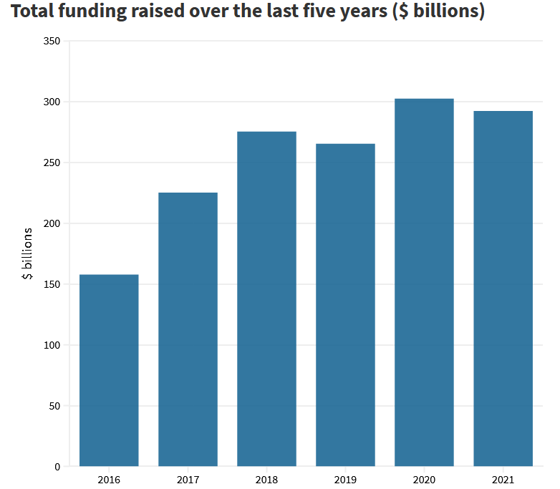

Serving Startup Founder’s needs with Acceleration Programs

Most of the times startup teams apply to several programs or look for different types of help or institutional assistance. As mentioned before the startup type as well as the maturity of each case can determine the suitability to join an acceleration program (or not). The answer to the question if a startup should join an accelerator program or depends on a series of reasons that may differ depending also on the program specifications as well as the startup founders’ priorities.

An indicative scenario between assessing the need to join a non-investing/very early-stage accelerator and an investing accelerator program is provided. There can be more viewpoints as there are more programs operating in the acceleration spectrum. The scenario is based on a similar hypothesis building for startups by the Silicon Valley Bank ( <https://www.svb.com/> ) and adapted its parameters with experiential learning insights.



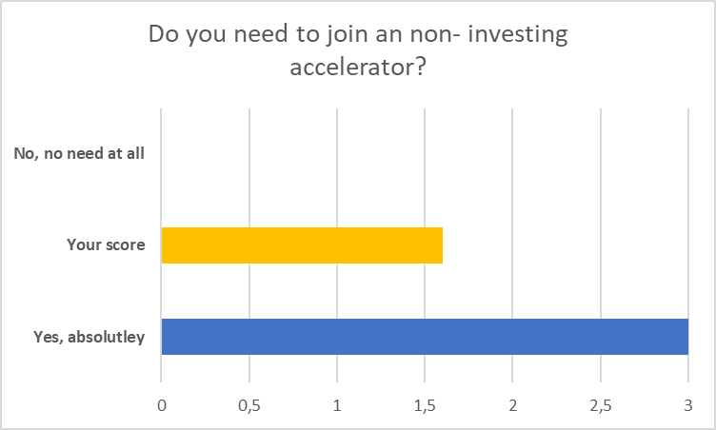

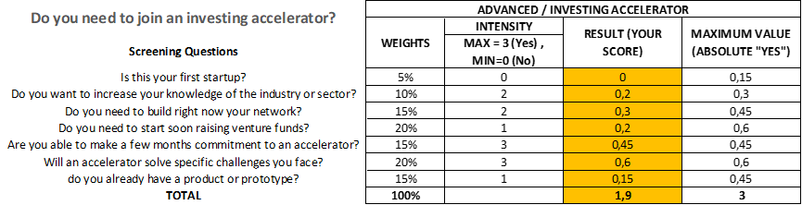

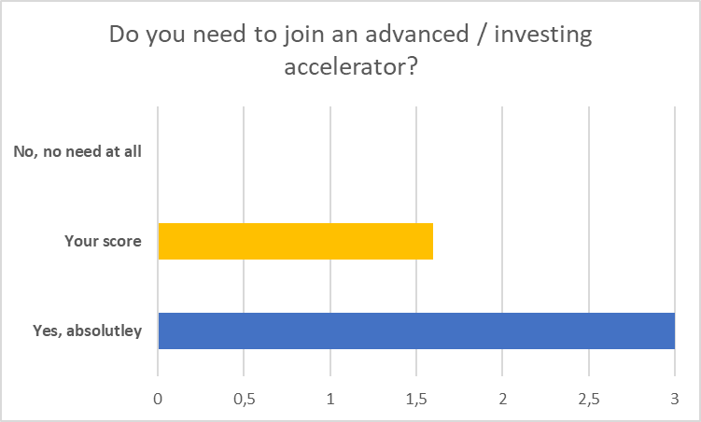

Interpreting Startup Founders

In an average acceleration process program mentors are faced with some commonly met challenges starting from the perceptions of the founders that can be less or more biased. As mentioned, a [startup idea = a great idea – reality] therefore a mentor’s job is solving this equation and shed some light in any given understanding and presentation of the startup “solution”.

There is a lot of mythology around a new venture. Startup founders often are over-optimistic on the uniqueness of the solution, the absence of competition and the desire of the market to adopt the new product. Truth is that things are less positively looking and way more difficult than presented. The lack of basic skills and experience on behalf of the founders can also signal concerning thoughts for the mentor regarding the ability of the startup team to implement.

Absence of adequate primary market research and reliance to secondary research data alone can also become a source of trouble for the startup. It is the mentor’s obligation to point out such a weakness with market validation and advise the team to carefully examine the market pain

The ability to make money from selling the solution is the ultimate test on the revenue model hypothesis, Many times consumer habits and adoption parameters are underestimated, thus leading to unpleasant surprises when launching the product to a market. Mentors have to revisit the assumptions calculated in the sales plan and prep the founders.

Statistically speaking, the average startup will fail due to absence of market need, inability to deliver a solution that works as promised, or because there is a conflict between founders. Mentor’s can help startups overcome a crisis, deal with too much empathy, pivot to a better solution or even quit if it’s the right thing to do.

Common Statements that can be “signals” for focused work in an accelerator can be the following:

*“It’s Brilliant!!”*: Explore the Idea to turn a Concept to MVP

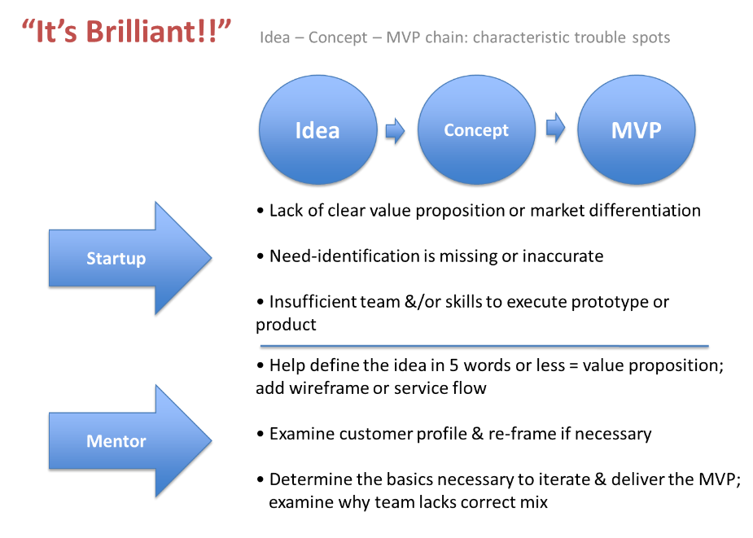

*“It’s Wanted!!”*: Look for confirmation via Market Research, Product Validation, Market Fit

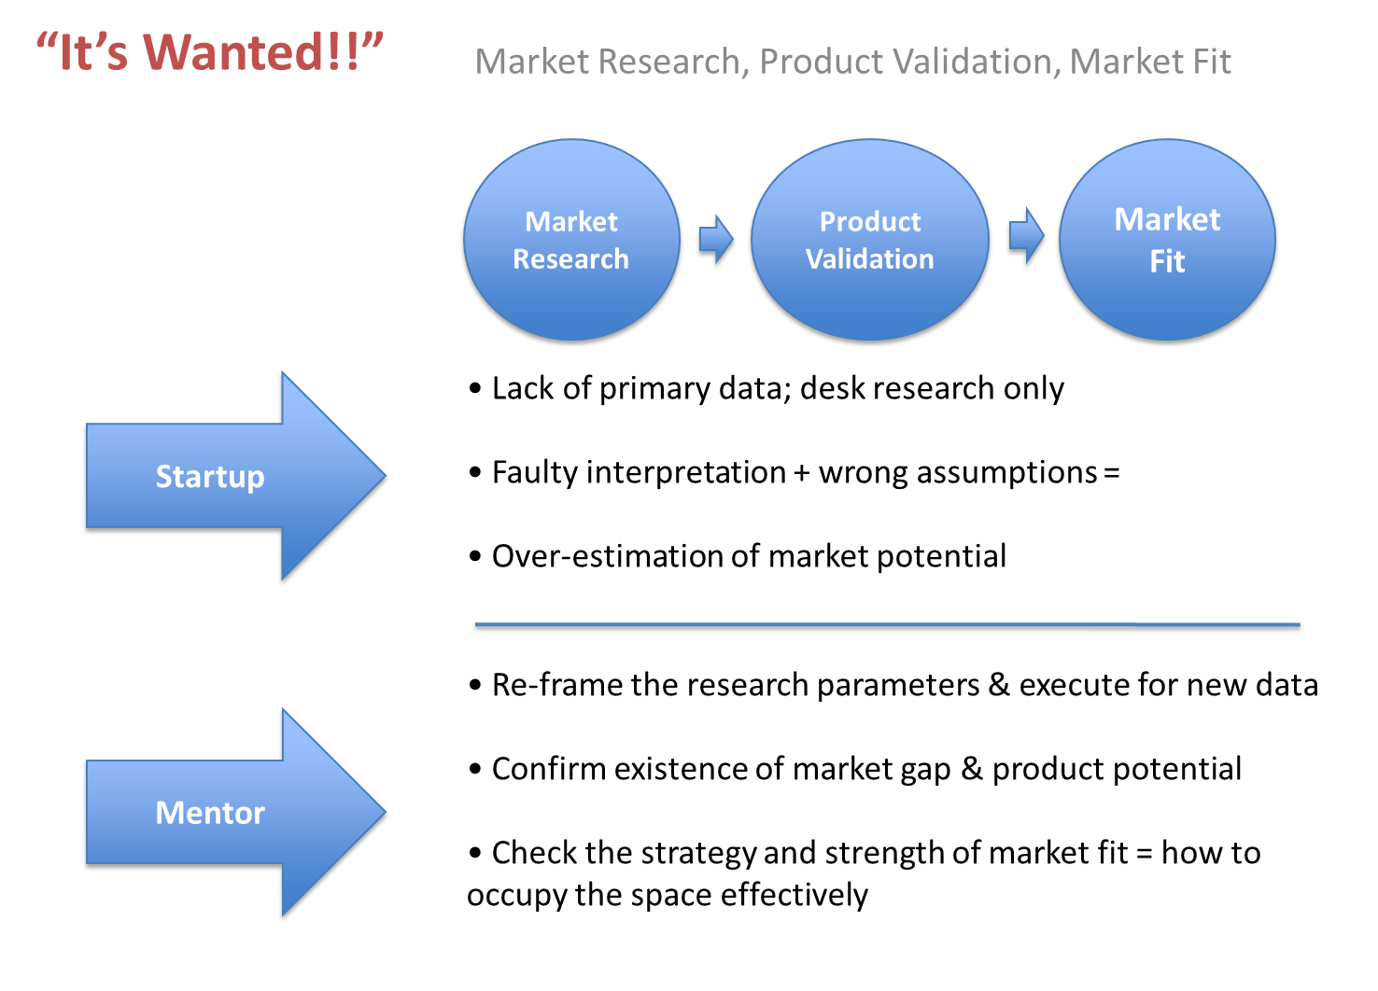

*“It’s Monetizable!!”*: Analyze the USP and the dreaded Business Model

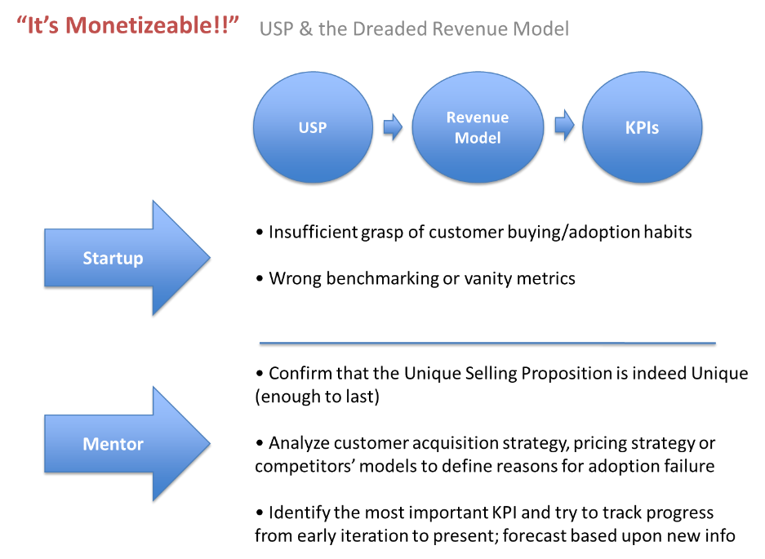

*“It’s … Not!!”*: Brace for Pivots, Splits, and Fails

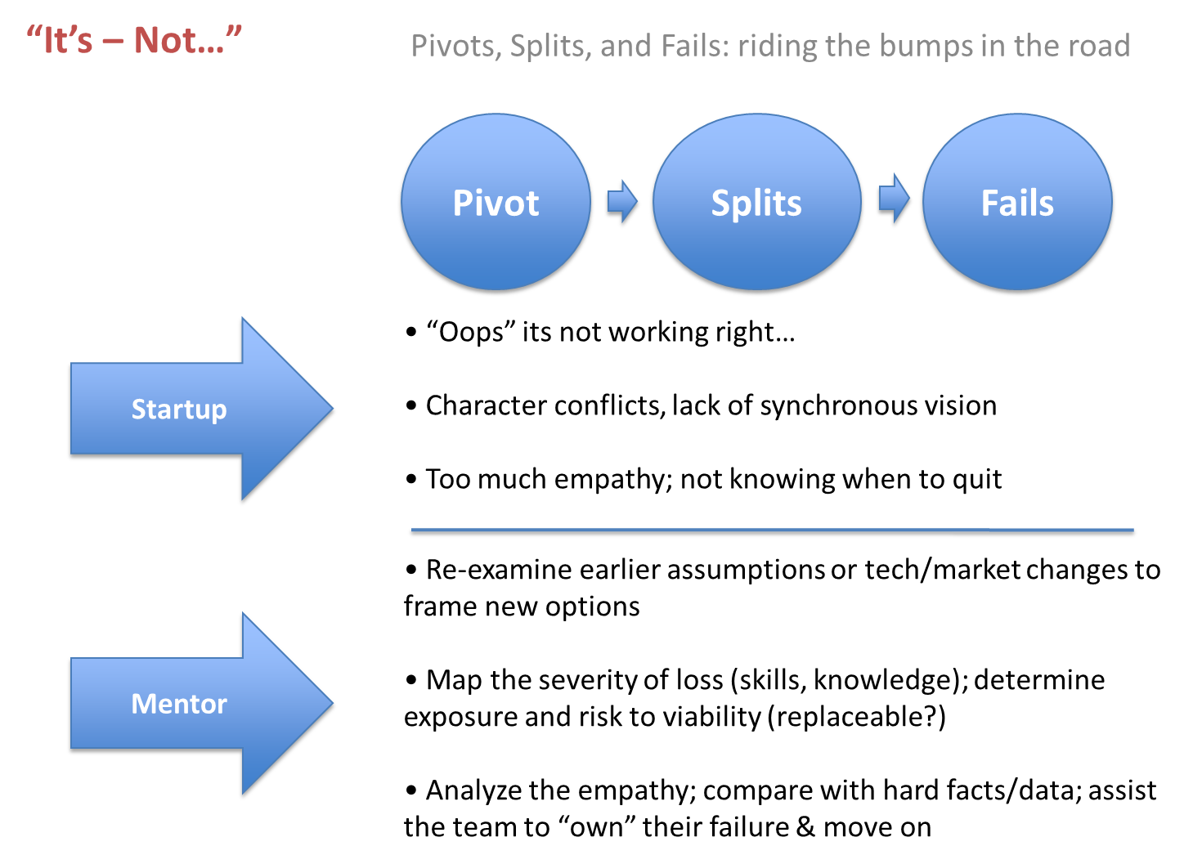

Effective mentoring should be able to adapt to each given situation and combine standard practices with the right approach to each founders’ team; in other words, effective mentoring = adaptive mentoring. Since not all projects are created equal, there are different types of startups it is the responsibility of the program organizers to screen early and filter the applicants and participants project parameters in order to provide the right mentoring for the job while applying realism in their approach.

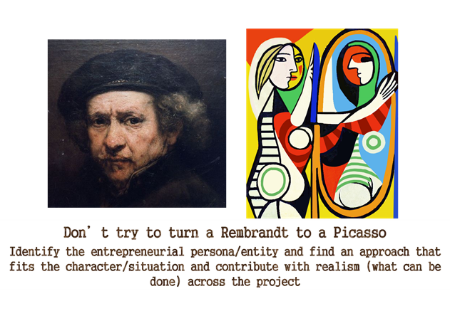

There are many ways to track your mentoring progress available but keeping score is important. Using traditional pen and paper notes or even software can help you remember your engagement with different startups when you operate in an acceleration program or work/act as a mentor with various startups.

Example: A Mentor’s Canvas is used to tackle specific challenges

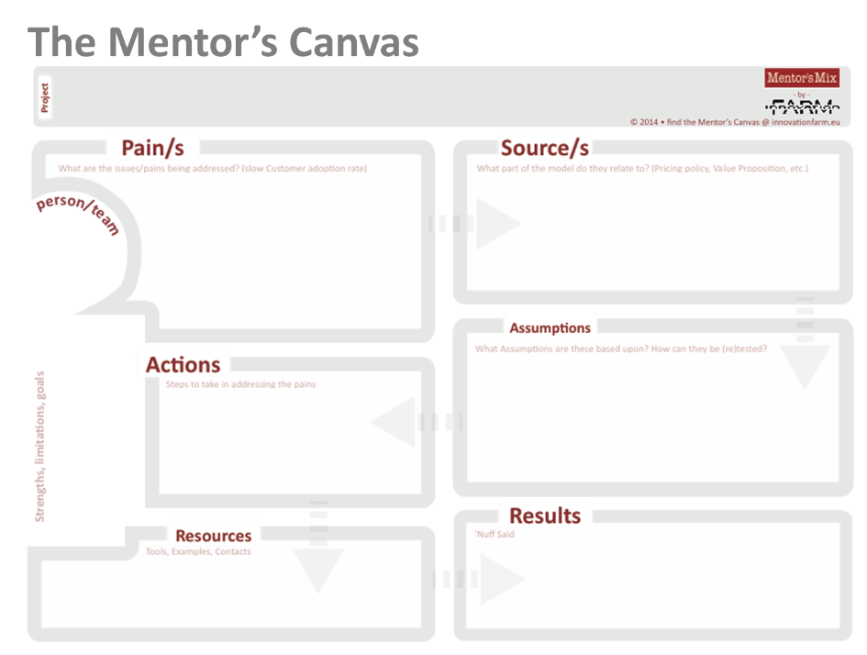

Example: A Startup thermometer is used to rate a mentor’s perception on the weaknesses spotted in four key areas other than product.

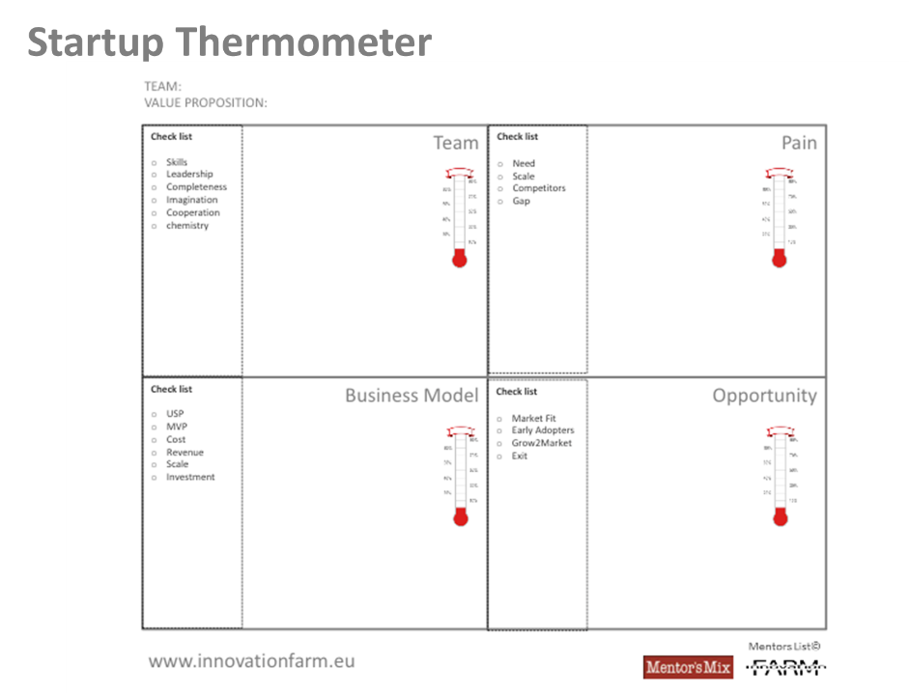

The Mentor – Mentee Relationship

The mentor – mentee relationship, is built on trust and mutual effort that acts as a continuous osmosis and learning for both sides. Mentoring most of the times is a challenging task. On the startup side founders are usually recipients of an advice cataclysm especially when they talk to many different mentors, advisors or attend multiple startup acceleration or bootcamps programs concurrently. It is critical for both sides to be able to weight their time, absorb but ultimately be able to leverage information received.

According to Confucius famous Chinese philosopher, teacher and political figure, there are 3 ways to learn wisdom:

* reflection, which is noblest
* imitation, which is easiest
* experience, which is hardest.

Meaningful reflection is the best since it strengthens your capacity to absorb and learn. Learning by reflection makes the best understanding of untrained subjects. Unfortunately, it requires time, focus, consistency and discipline, attributes that are not always found in startup teams. A mentor’s job can be more effective when balances the right combination of mainly reflection and experience, guiding the process while keeping an open mind.

Many startup supporting organizations have adopted basic principles under which their mentors operate. One of the most known is the Techstars’ Mentor Manifesto (<https://www.techstars.com/the-line/advice/mentor-manifesto>) , created by co–founder David Cohen below:

Tech Stars Mentor Manifesto

* Be socratic.
* Expect nothing in return (you’ll be delighted with what you do get back).
* Be authentic / practice what you preach.
* Be direct. Tell the truth, however hard.
* Listen too.
* The best mentor relationships eventually become two way.
* Be responsive.
* Adopt at least one company every single year. Experience counts.
* Clearly separate opinion from fact.
* Hold information in confidence.
* Clearly commit to mentor or do not. Either is fine.
* Know what you don’t know. Say I don’t know when you don’t know. “I don’t know” is preferable to bravado.
* Guide, don’t control. Teams must make their own decisions. Guide but never tell them what to do. Understand that it’s their company, not yours.
* Accept and communicate with other mentors that get involved.
* Be optimistic.
* Provide specific actionable advice, don’t be vague.
* Be challenging/robust but never destructive.
* Have empathy. Remember that startups are hard.

Founders prefer straight forward, clean advice. Especially when rigorous process taking place in acceleration programs suggest the need to expedite things fast instead of philosophically wonder. Unfortunately, just dictating advise takes away value from the learning process. It’s important to be direct speaking your mind and addressing hard truths, but with an authentic demonstration of what you mean, and by allowing founders to reach the desired/targeted conclusion own their own can help more. It’s a tricky balance to achieve but it can provide the best of both worlds.

The Mentor – Mentee relationship starts with listening and continuous with responsiveness. It’s the Mentor’s responsibility to weigh how much time and commitment to give in a startup. It’s also the Mentor’s responsibility to know what advice is best for any given moment or simply know that don’t know.

A useful way for the mentor who is driving the train is to apply some metrics in the basics of the mentor – mentee process like:

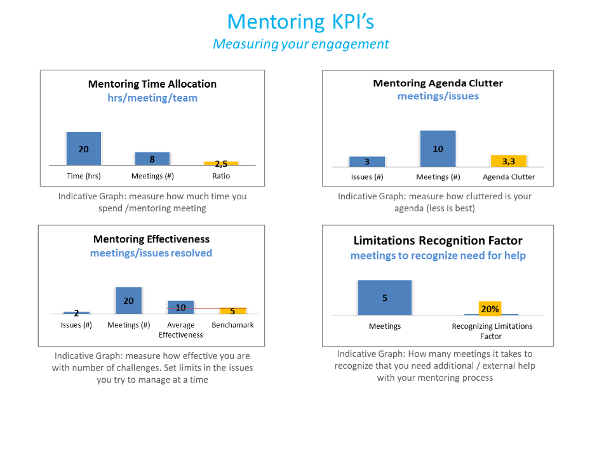

Supplementary to program mentors, external advisors are vital to an acceleration process. Advisors can offer valuable advice through their professional experience and networking when your company is in a formative position as well as after that. Advisors operate as “industry experts” opening doors or sharing their experiences in the sectors they operate. This way, the advisors become a valuable addition to an acceleration program or incubator and fill the gaps that everyday engagement via the program’s mentors cannot support.

Sometimes, startups desire a more frequent and formal type of help on behalf of the advisors but without having the capital to compensate advisors, they investigate alternative ways to facilitate that like offering equity (a small share of the company) or success fee (% of income from a sales contract or funding). While success fee operates as a variable cost and is an easier way to calculate, equity is often seen as a more effective for Advisors as it creates a longer-term relationship pointing to some common end-goal which reflects expectations for a high valuation and an “exit” down the road. In that token advisors are offered a small % (usually 0,5-1,5%) of shares in the startup they engage which in the long run they could sell to a third party buying their share at (hopefully) substantially higher value compared to what it measured when it was granted. An example of such Founder-Advisor Agreement is “FAST” implemented by Founder’s Institute; an international accelerator <https://fi.co/fast>

In a typical agreement Founder-Advisor Agreement certain areas that describing the relationship are depicted such as:

* the rules of engagement and time commitments on behalf of the advisor
* intellectual property and non-disclosure restrictions
* conflicts of interest
* the amount of % of shares an advisor will receive
* the price per share (if any) and the time/conditions of shares ownership
* valuation cap
* transferability of shares
* termination clauses

# Videos

Startups vs Small Business: what's the difference?

<https://www.youtube.com/watch?v=k26DOtwPN7s&t=94s>

Steve Blank - Types of Startups. Duration: 8:30

<https://www.youtube.com/watch?v=A2cBrL_pcj4>

5 Business Ideas That Will Be BIG for 2021 (But Easy to Start!) 5 Business Ideas That Will Be BIG for 2021 (But Easy to Start!). Durartion: 16:00

<https://www.youtube.com/watch?v=Ljxonpqa7O0>

Tips For Mentees AND Mentors To Create Successful Mentoring Relationships For Startups. Duration. 9:00

<https://www.youtube.com/watch?v=pwYxEJAxtlw>

5 Questions You Should Never Ask Your Mentor. Duration. 6:45

<https://www.youtube.com/watch?v=YMFlWvBCYUE>

**Recommended Readings**

The Startup Mentor - How brilliant mentors can help you launch your company, Authors: Maia Patrick Donohue

The Four Steps to the Epiphany, Author: Steven Gary Blank

HBR: 6 Things Every Mentor Should Do, by Vineet Chopra and Sanjay Saint (https://hbr.org/2017/03/6-things-every-mentor-should-do)

The Average Age of a Successful Startup Founder Is 45 by Pierre Azoulay, Benjamin F. Jones, J. Daniel Kim, and Javier Miranda

https://hbr.org/2018/07/research-the-average-age-of-a-successful-startup-founder-is-45